Ashwini



Capstone Project

Sales Forecasting – Notes 2

Contents

Model Building and Interpretation. 3

Insights from EDA 3

Coolers 4

Chennai 4

Additive and Multiplicative Decomposition 4

ACF and PACF Plots 4

Models 4

Mumbai 6

Additive and Multiplicative Decomposition 7

ACF and PACF Plots 7

Models 7

Cochin 8

Additive and Multiplicative Decomposition 9

ACF and PACF Plots 9

Models 9

Business Insights 11

Dry Iron 11

Mumbai 11

Additive and Multiplicative Decomposition 11

ACF and PACF Plots 11

Models 12

Kolkata 13

Additive and Multiplicative Decomposition 14

ACF and PACF Plots 14

Models 14

Hyderabad 16

Additive and Multiplicative Decomposition 16

ACF and PACF Plots 17

Models 17

Business Insights 19

Food Processor 19

Mumbai 19

Additive and Multiplicative Decomposition 19

ACF and PACF Plots 20

Models 20

Pune 22

Additive and Multiplicative Decomposition 22

ACF and PACF Plots 22

Models 23

Bangalore 25

Additive and Multiplicative Decomposition 25

ACF and PACF Plots 26

Models 26

Business Insights 28

Gas Stove 29

Mumbai 29

Additive and Multiplicative Decomposition 29

ACF and PACF Plots 29

Models 29

Cochin 32

Additive and Multiplicative Decomposition 32

ACF and PACF Plots 32

Models 32

Kolkata 34

Additive and Multiplicative Decomposition 35

ACF and PACF Plots 35

Models 35

Business Insights 37

Induction Cookers 38

Mumbai 38

Additive and Multiplicative Decomposition 38

ACF and PACF Plots 38

Models 39

Business Insights 41

Mixers 42

Mumbai 42

Additive and Multiplicative Decomposition 42

ACF and PACF Plots 42

Models 43

Business Insights 45

Oven Toaster Grill 45

Business Insights 45

Steam Iron 46

Business Insights 46

Overall Insights 46

# Model Building and Interpretation.

## Insights from EDA

* From the EDA performed in notes-1, the best selling product in cities have been considered
* 8 products have performed very good sales in cities
* Products considered for modelling are :
* Coolers, Dry Iron, Food Processor, Gas Stove, Induction Cookers, Mixers, Steam Iron , Oven Toaster Grill.
* Top 5 to 6 cities have been considered for modelling in all these product to predict the sales forecasting

# Coolers

Top 3 Cities have been considered here

## Chennai

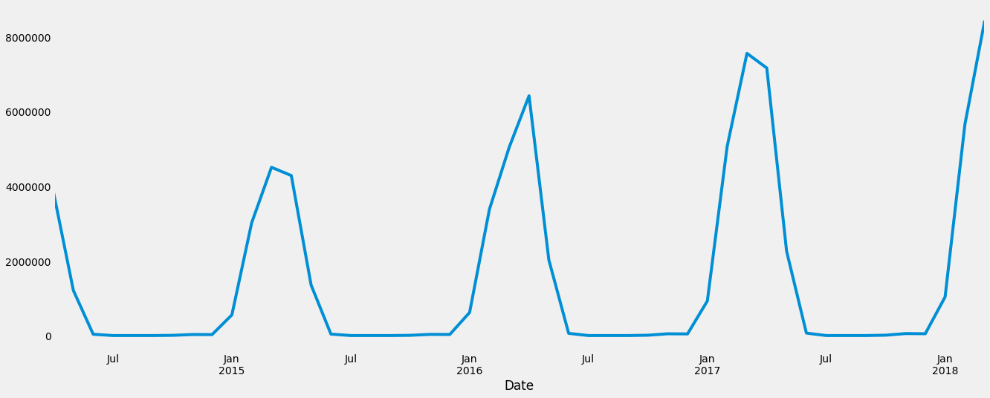

# Additive and Multiplicative Decomposition

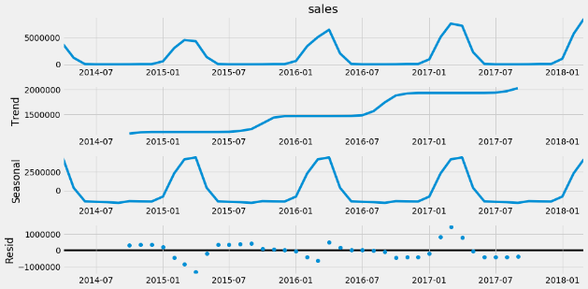

We observe there is seasonality in both the decompositions

# ACF and PACF Plots

Since the ACF plot is gradually decreasing and PACF plot suddenly cuts off to zero,

we will be needing a purely Seasonal AR Model.

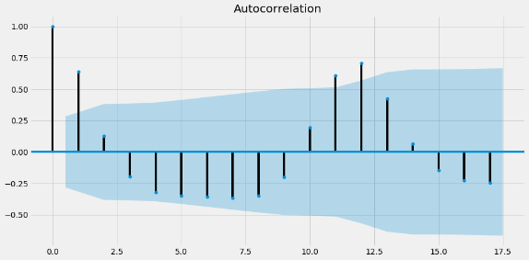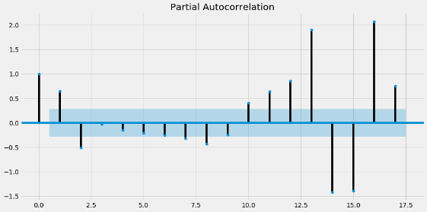

# Models

We have tried out various models and results shown below.

|  |  |
| --- | --- |
|  | **Test RMSE** |
| **Simple Average** | 6.56E+06 |
| **Alpha=0.995,SimpleExponentialSmoothing** | 7.79E+06 |
| **Alpha=0.1,SimpleExponentialSmoothing** | 6.67E+06 |
| **Alpha=0.6,Beta=0.8,DoubleExponentialSmoothing** | 6.63E+06 |
| **Alpha=0.0403,Beta=0.0001,Gamma=0.0001,TripleExponentialSmoothing** | 2.23E+06 |
| **Alpha=0.1,Beta=0.2,Gamma=1.0,TripleExponentialSmoothing** | 1.73E+06 |
| **SARIMA(0,1,0)(3,1,0)6** | 6.39E+15 |
| **SARIMA(0,1,0)(0,1,2)12** | 3.99E+12 |
| **Prophet** | 3.69E+12 |

Triple Exponential Smoothing have shown the best results for Chennai region.

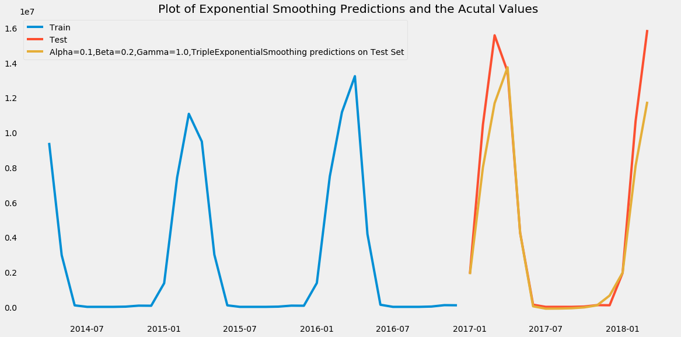

The above plot shows Actual vs Predicted data.

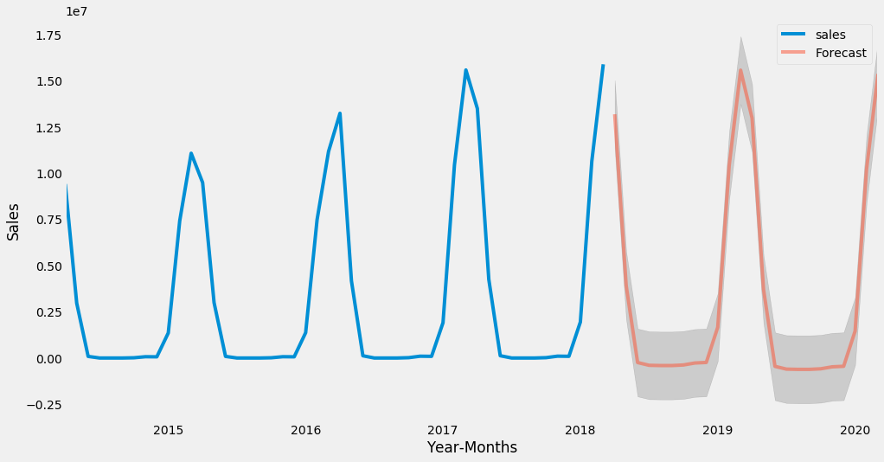

Applying Triple exponential to the full data set and sales have been high during Q1 and Q2, however, Q3 and Q4 have recorded almost nil sales.

## Mumbai

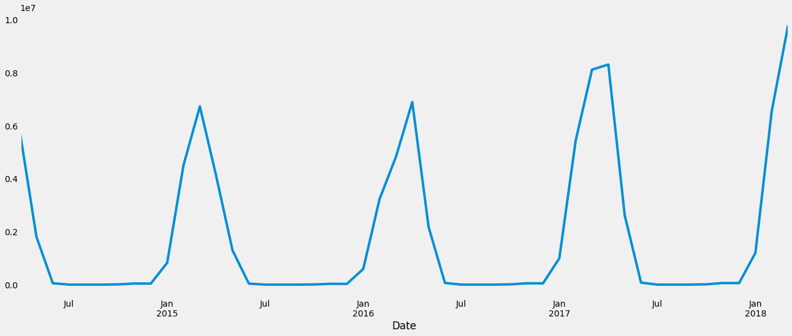

# Additive and Multiplicative Decomposition

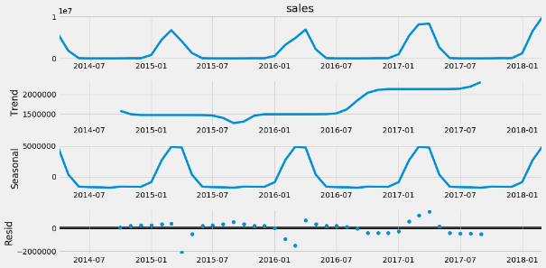 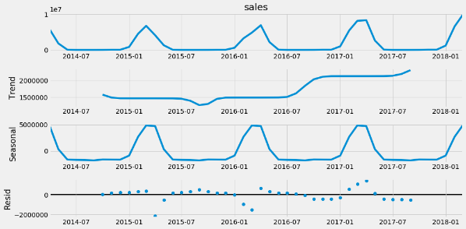

We observe there is seasonality in both the decompositions

# ACF and PACF Plots

Since the ACF plot is gradually decreasing and PACF plot suddenly cuts off to zero,

we will be needing a purely Seasonal AR Model.

 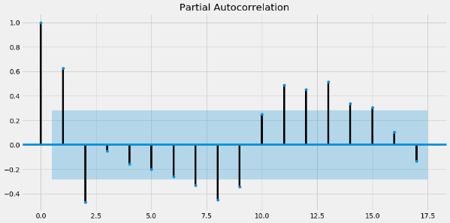

# Models

We have tried out various models and results shown below.

|  |  |
| --- | --- |
|  | **Test RMSE** |
| **Alpha=0.2,Beta=0.7,Gamma=0.6,TripleExponentialSmoothing** | 1.06E+06 |
| **Alpha=0.5353,Beta=0.0001,Gamma=0.0001,TripleExponentialSmoothing** | 1.70E+06 |
| **Alpha=0.1,Beta=0.9,DoubleExponentialSmoothing** | 3.60E+06 |
| **Simple Average** | 3.87E+06 |
| **Alpha=0.1,SimpleExponentialSmoothing** | 3.94E+06 |
| **Alpha=0.995,SimpleExponentialSmoothing** | 4.53E+06 |
| **SARIMA(0,1,0)(0,1,2)12** | 3.53E+12 |
| **SARIMA(0,1,0)(0,1,2)12** | 3.53E+12 |
| **Prophet** | 3.61E+12 |
| **SARIMA(0,1,0)(3,1,0)6** | 8.12E+12 |

Triple Exponential Smoothing have shown the best results for Mumbai region.

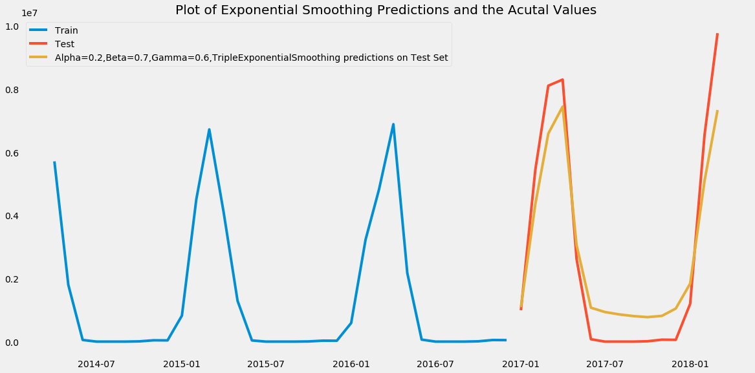

The above plot shows Actual vs Predicted data.

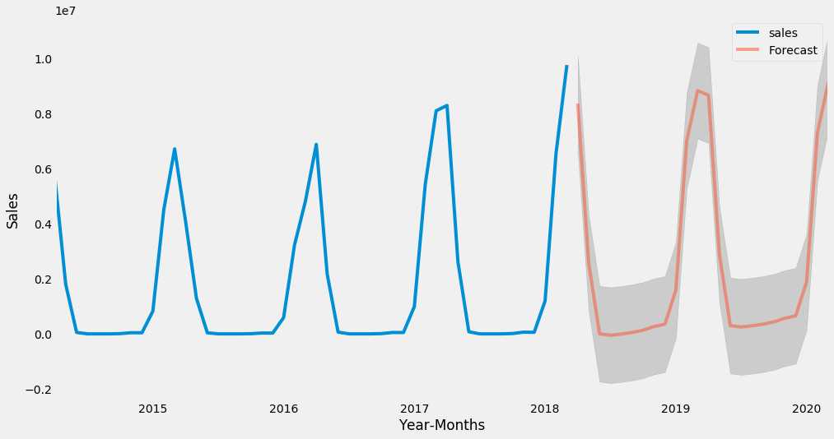

## Cochin

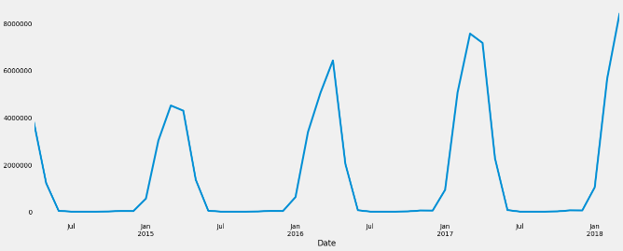

# Additive and Multiplicative Decomposition

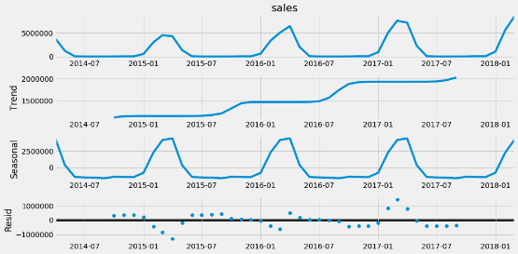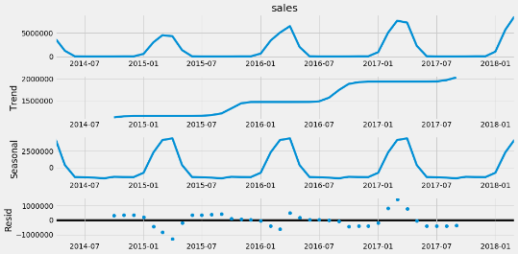

We observe there is seasonality in both the decompositions

# ACF and PACF Plots

Since the ACF plot is gradually decreasing and PACF plot suddenly cuts off to zero,

we will be needing a purely Seasonal AR Model.

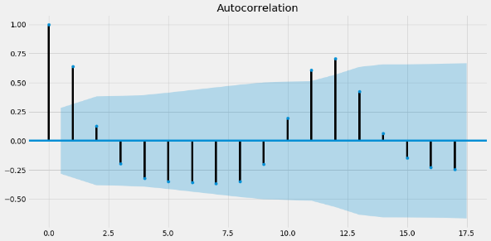 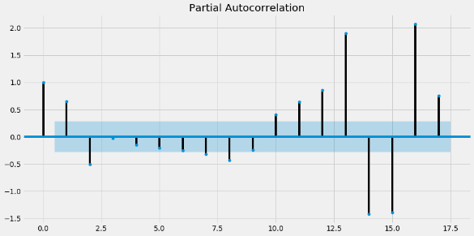

# Models

We have tried out various models and results shown below.

|  |  |
| --- | --- |
|  | **Test RMSE** |
| **Alpha=0.1,Beta=0.2,Gamma=1.0,TripleExponentialSmoothing** | 1.14E+06 |
| **Alpha=0.5353,Beta=0.0001,Gamma=0.0001,TripleExponentialSmoothing** | 1.72E+06 |
| **Alpha=0.6,Beta=0.7,DoubleExponentialSmoothing** | 3.39E+06 |
| **Simple Average** | 3.44E+06 |
| **Alpha=0.1,SimpleExponentialSmoothing** | 3.49E+06 |
| **Alpha=0.995,SimpleExponentialSmoothing** | 4.01E+06 |
| **SARIMA(0,1,0)(0,1,2)12** | 1.75E+12 |
| **SARIMA(0,1,0)(3,1,0)6** | 1.78E+13 |

Triple Exponential Smoothing have shown the best results for Cochin region.

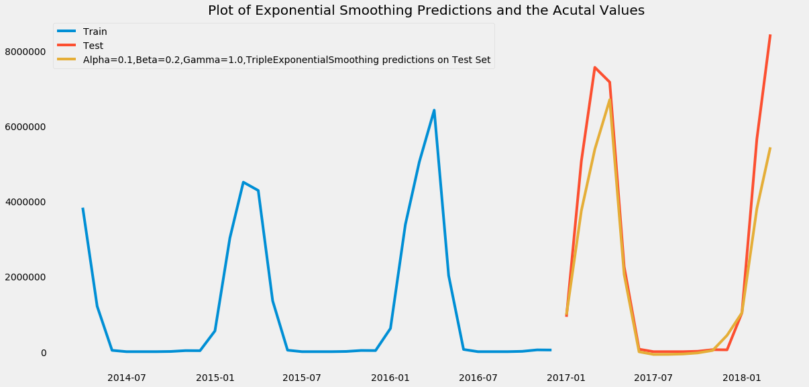

The above plot shows Actual vs Predicted data.

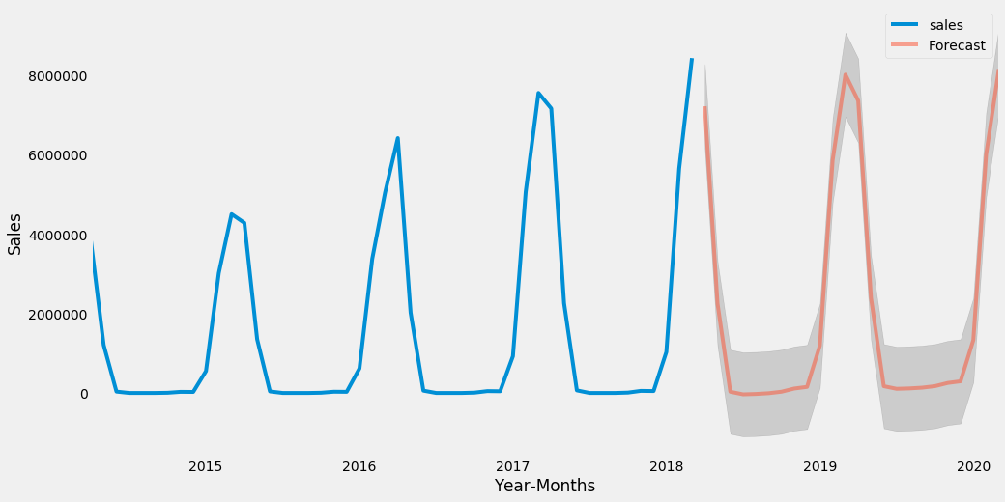

# Business Insights

* Coolers have seasonal components and hence the forecast also yield good sales across the years
* Other cities Bangalore, Ahmd, Hyderabad give good sales and its forecast also looks good in the upcoming years
* Coolers production should be give high priority because of maximum sales during Q1 and Q2.
* Others cities such as Patna, Delhi and Kolkata yields less profit, however the seasonal profits are consistent through the year.

# Dry Iron

## Mumbai

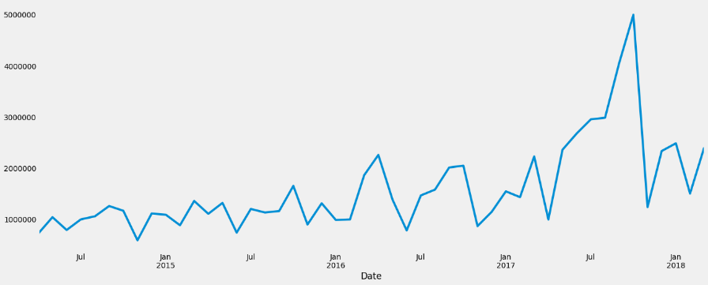

# Additive and Multiplicative Decomposition

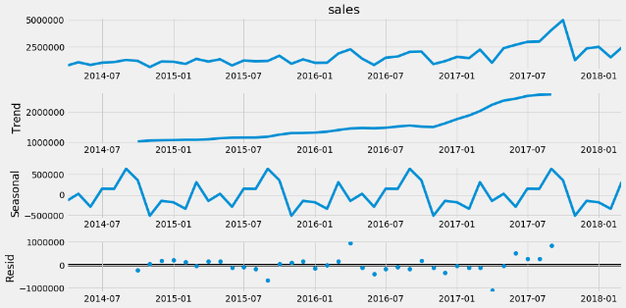 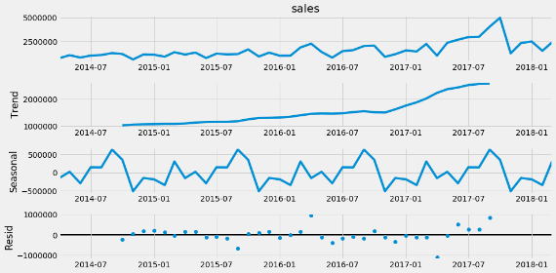

We observe there is no seasonality in both the decompositions

# ACF and PACF Plots

Since the ACF plot is gradually decreasing and PACF plot suddenly cuts off to zero,

we will be needing a purely Seasonal AR Model. Let us see, if the Arima model gives us results

in accordance to this observation.

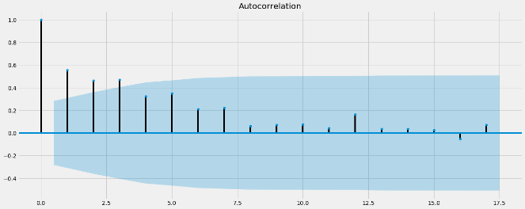 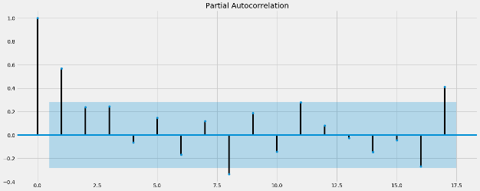

# Models

We have tried out various models and results shown below.

|  |  |  |
| --- | --- | --- |
|  | **Test RMSE** | **Test MAPE** |
| **ARIMA(1,0,1)** | 2.76E+01 | 42.222772 |
| **Alpha=0.1,Beta=0.4,DoubleExponentialSmoothing** | 1.03E+06 | 188.7076 |
| **Alpha=0.1,Beta=0.2,Gamma=0.1,TripleExponentialSmoothing** | 1.10E+06 | 27.613087 |
| **Alpha=0.005,Beta=0.0001,Gamma=0.0001,TripleExponentialSmoothing** | 1.27E+06 | 32.162831 |
| **Alpha=0.2,SimpleExponentialSmoothing** | 1.44E+06 | 39.153727 |
| **Alpha=0.995,SimpleExponentialSmoothing** | 1.44E+06 | 37.658553 |
| **Simple Average** | 1.59E+06 | NaN |
| **Prophet** | 1.13E+12 | NaN |
| **SARIMA(0,0,0)(3,0,0)12** | 6.88E+12 | 100 |

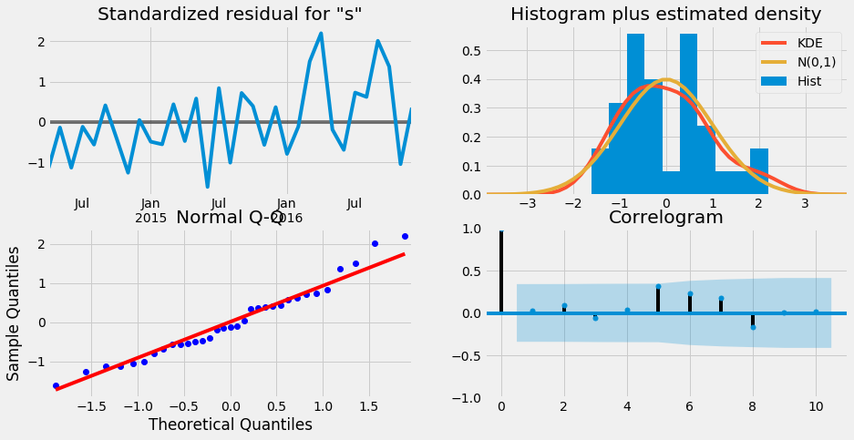

ARIMA have shown the best results for Chennai region.

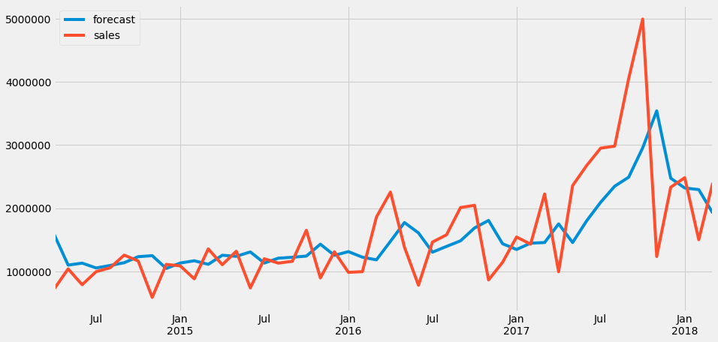

The above plot shows Actual vs Predicted data.

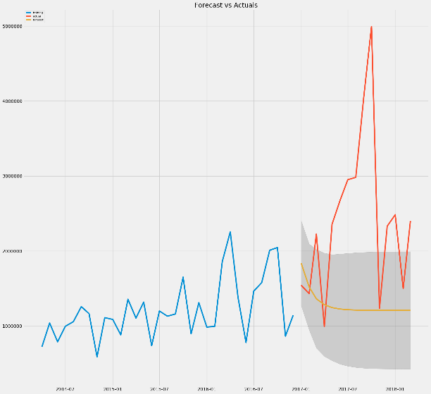

## Kolkata

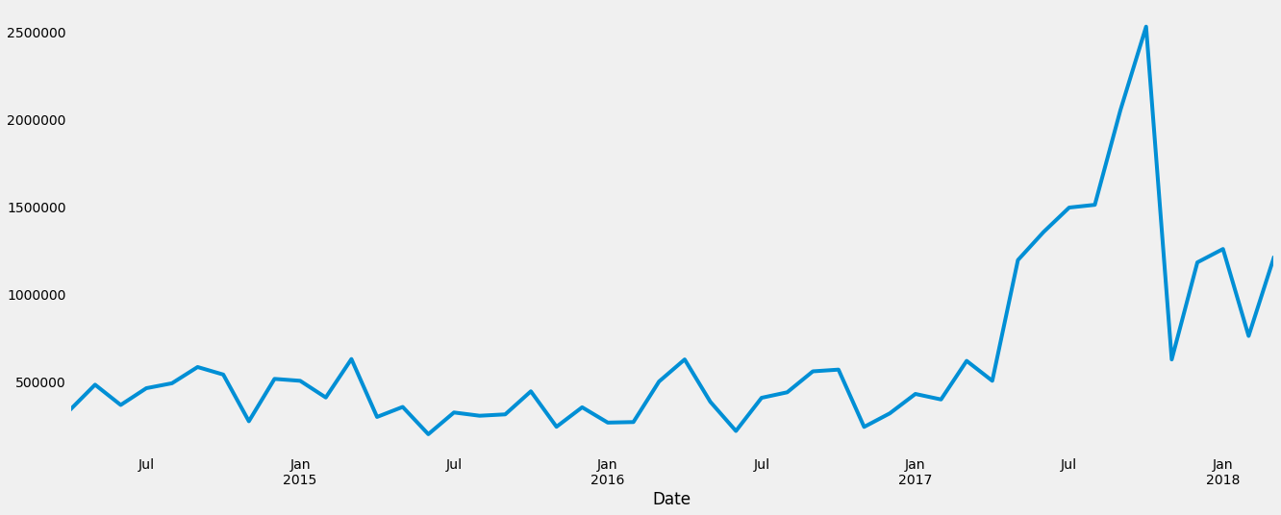

# Additive and Multiplicative Decomposition

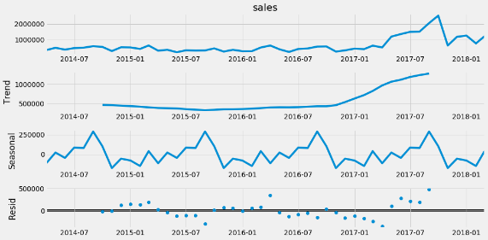 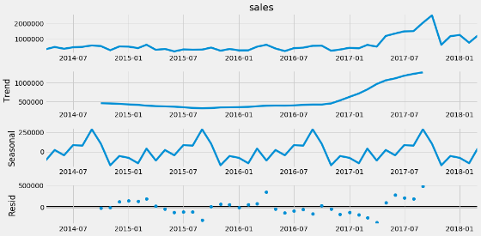

We observe there is no seasonality in both the decompositions

# ACF and PACF Plots

Since the ACF plot is gradually decreasing and PACF plot suddenly cuts off to zero,

we will be needing a purely Seasonal AR Model. Let us see, if the Arima model gives us results

in accordance to this observation.

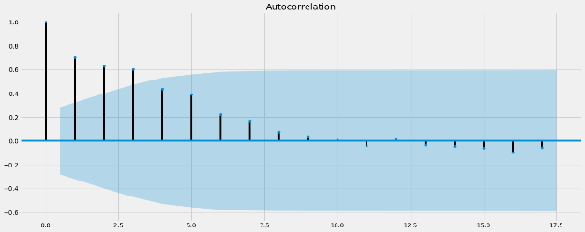 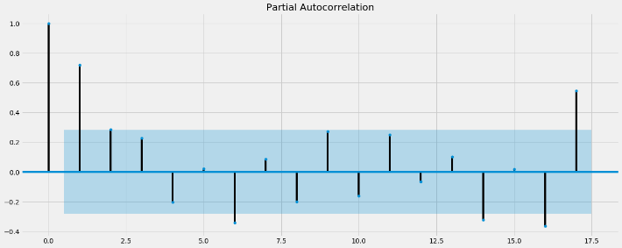

# Models

We have tried out various models and results shown below.



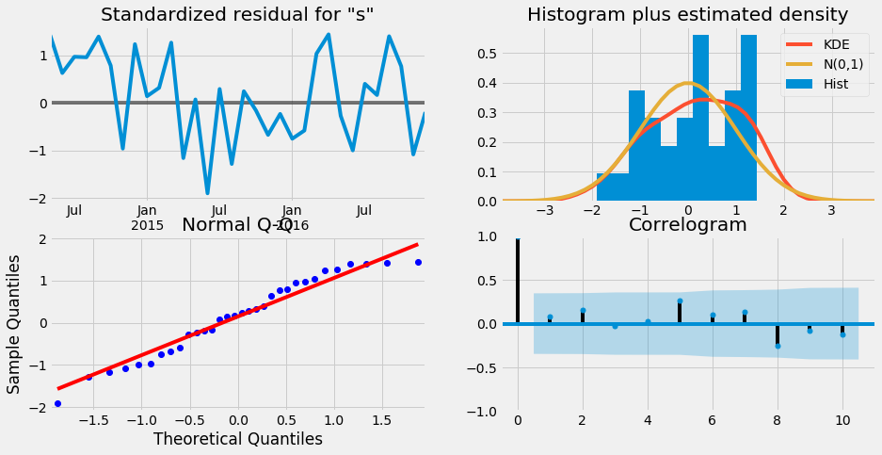

ARIMA have shown the best results for Kolkata region.

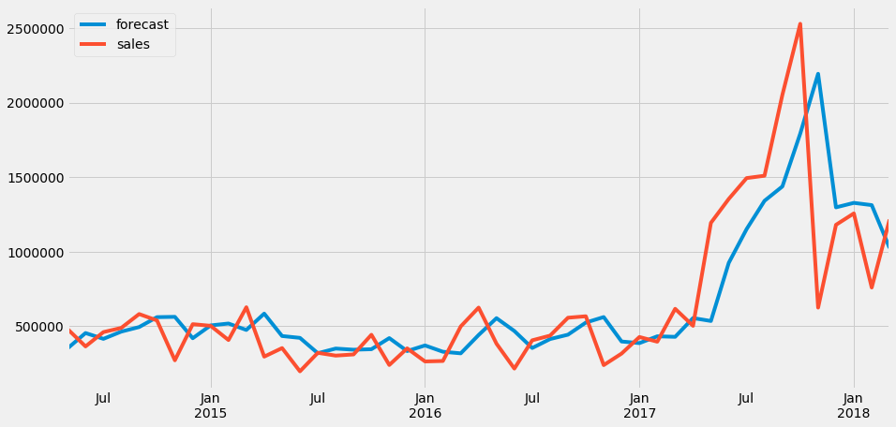

The above plot shows Actual vs Predicted data.

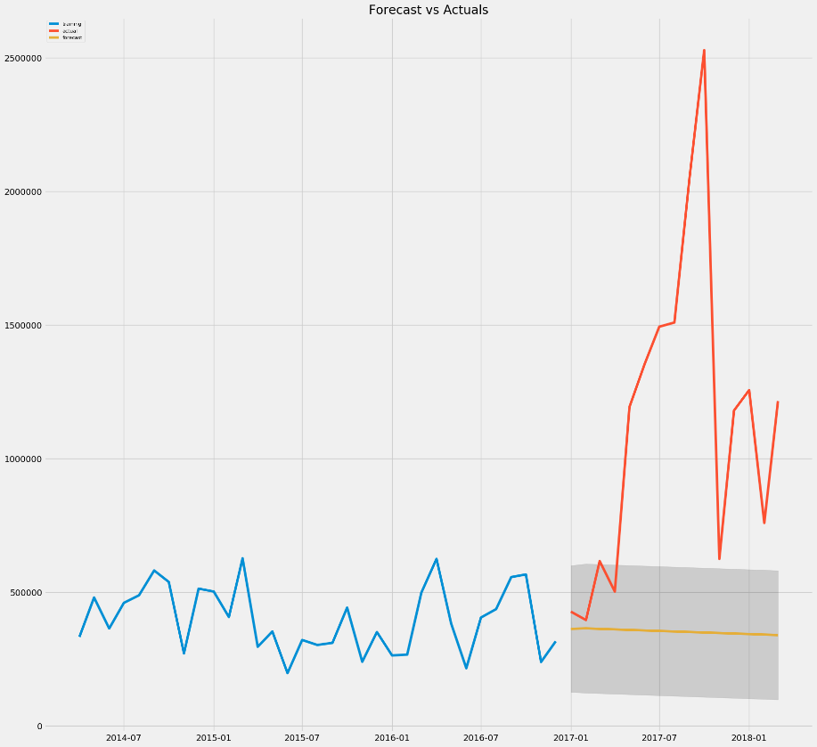

## Hyderabad

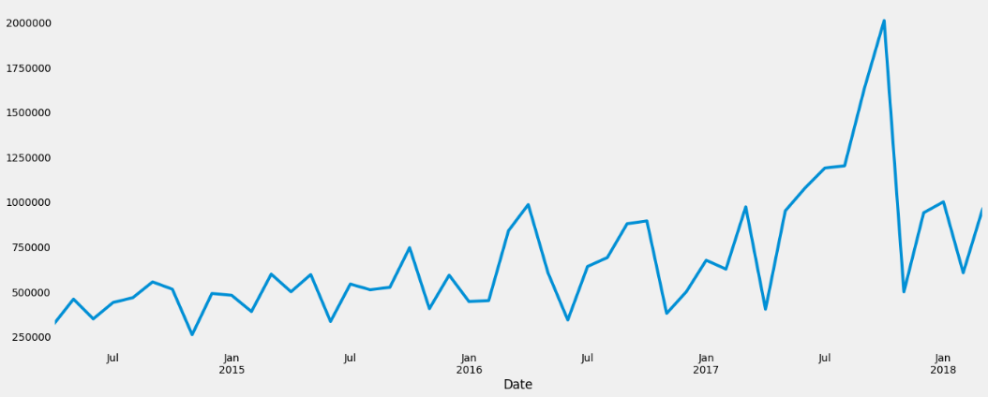

# Additive and Multiplicative Decomposition

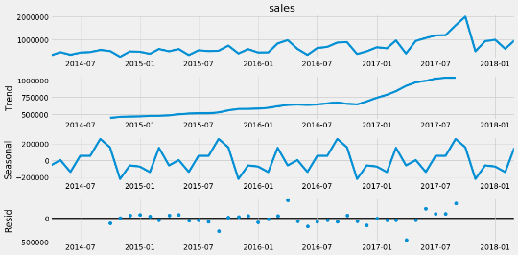 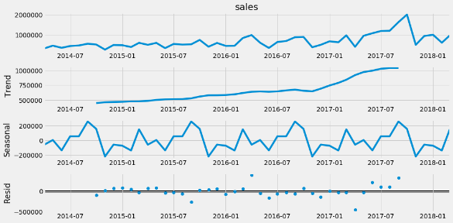

We observe there is no seasonality in both the decompositions

# ACF and PACF Plots

Since the ACF plot is gradually decreasing and PACF plot suddenly cuts off to zero,

we will be needing a purely Seasonal AR Model. Let us see, if the Arima model gives us results

in accordance to this observation.

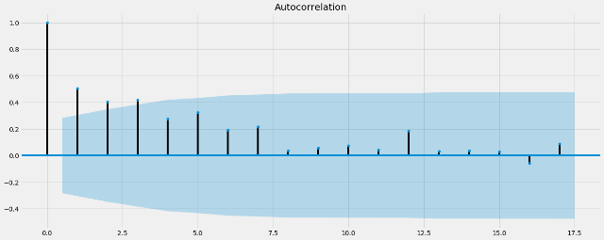 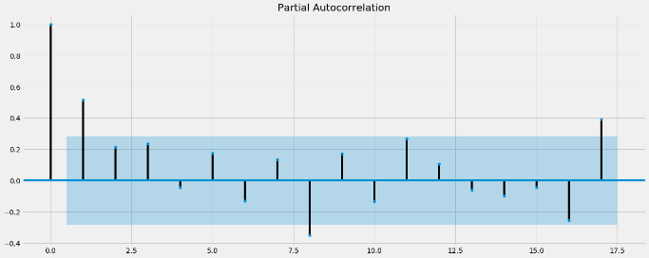

# Models

We have tried out various models and results shown below.

|  |  |  |
| --- | --- | --- |
|  | Test RMSE | Test MAPE |
| **ARIMA(1,0,1)** | 2.67E+01 | 4.02E+01 |
| **Alpha=0.1,Beta=0.4,DoubleExponentialSmoothing** | 4.06E+05 | 3.65E+01 |
| **Alpha=0.1,Beta=0.2,Gamma=0.1,TripleExponentialSmoothing** | 4.19E+05 | 2.67E+01 |
| **Alpha=0.005,Beta=0.005,Gamma=0.0001,TripleExponentialSmoothing** | 4.50E+05 | 2.75E+01 |
| **Alpha=0.2,SimpleExponentialSmoothing** | 5.50E+05 | 3.62E+01 |
| **Alpha=0.338,SimpleExponentialSmoothing** | 5.50E+05 | 3.62E+01 |
| **Simple Average** | 6.06E+05 | NaN |
| **Prophet** | 1.86E+11 | NaN |
| **SARIMA(0,0,0)(0,0,3)12** | 1.13E+12 | 1.00E+02 |

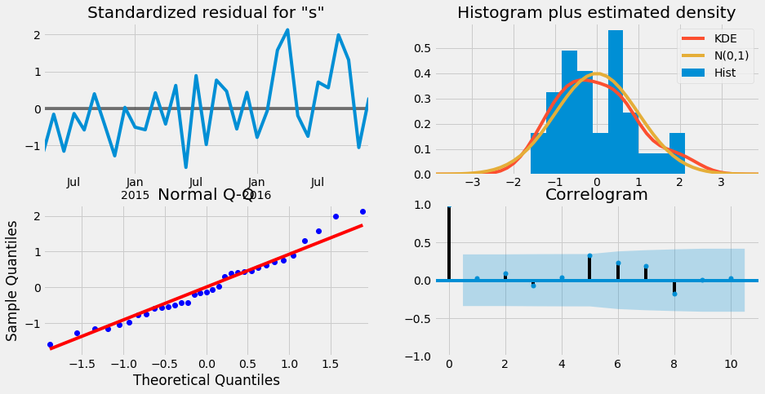

ARIMA have shown the best results for Hyderabad region.

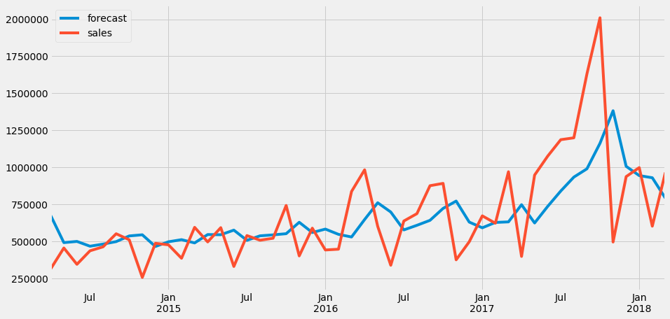

The above plot shows Actual vs Predicted data.

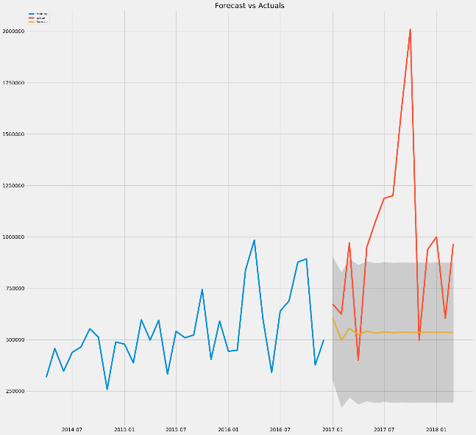

# Business Insights

* Dry Iron do not have seasonal components. Mumbai , Kolkata and Hyderabad yields highest sales across the years
* Other cities Patna, bangalore and Cochin give good sales and its forecast also looks good in the upcoming years
* Others cities such as Delhi and chennai yields less profit, however the seasonal profits are consistent through the year.
* All cities yields good sales from 2014 to 2018, hence sales is prone to go up in the upcoming years

# Food Processor

## Mumbai

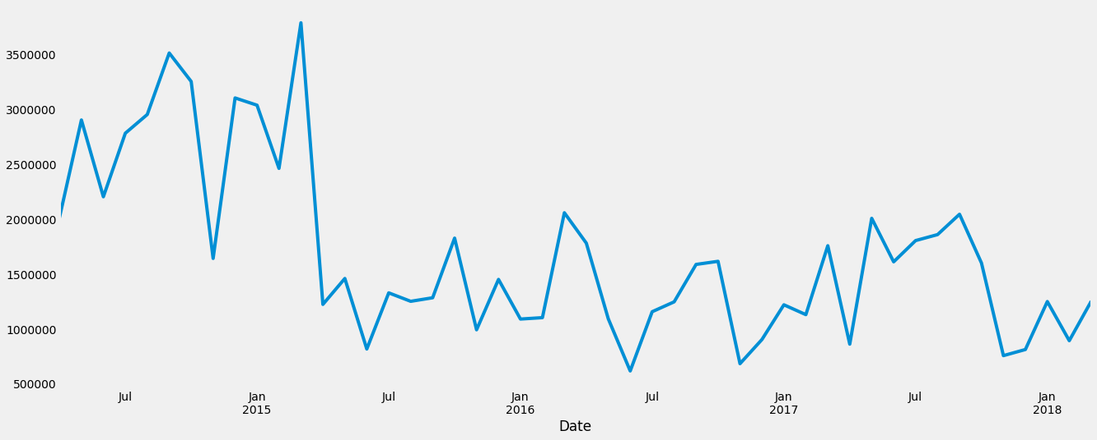

# Additive and Multiplicative Decomposition

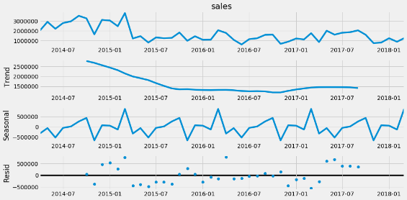 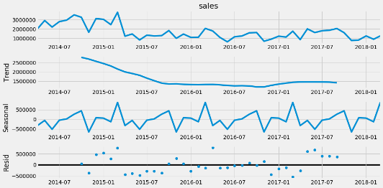

We observe there is no seasonality in both the decompositions

# ACF and PACF Plots

Since the ACF plot is gradually decreasing and PACF plot suddenly cuts off to zero,

we will be needing a purely Seasonal AR Model. Let us see, if the Arima model gives us results

in accordance to this observation.

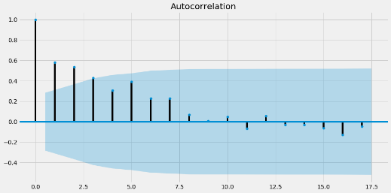 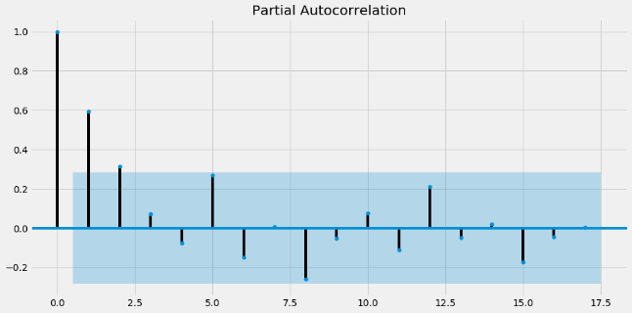

# Models

We have tried out various models and results shown below.



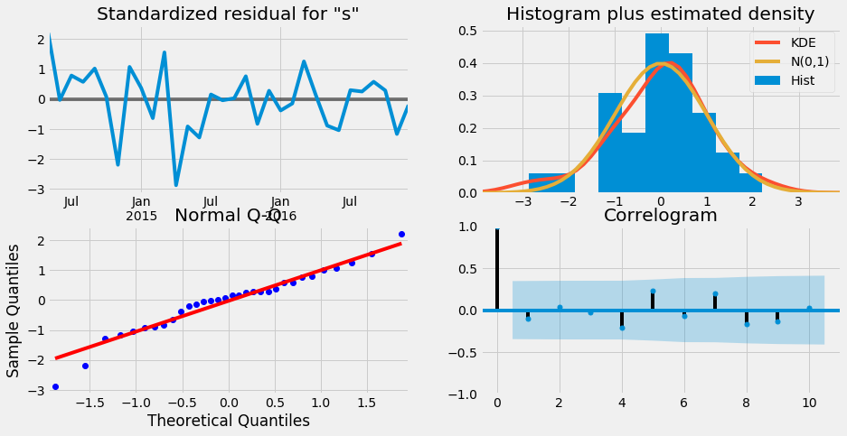

ARIMA have shown the best results for Mumbai region.

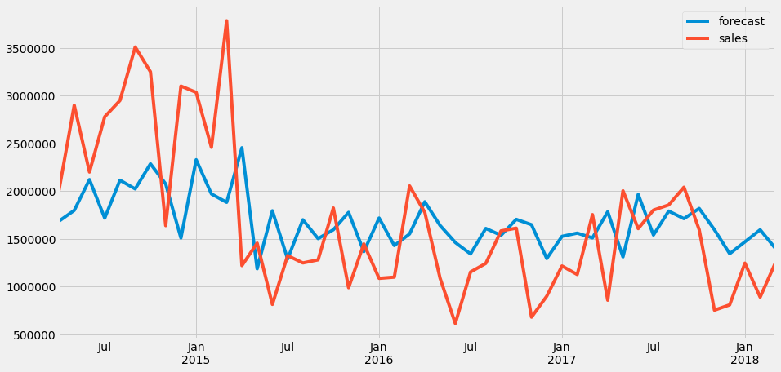

The above plot shows Actual vs Predicted data.

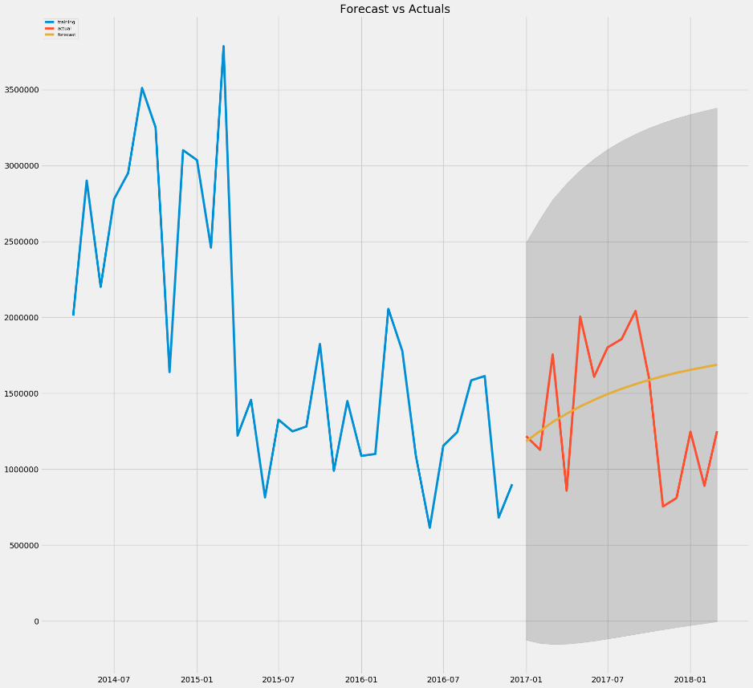

## Pune

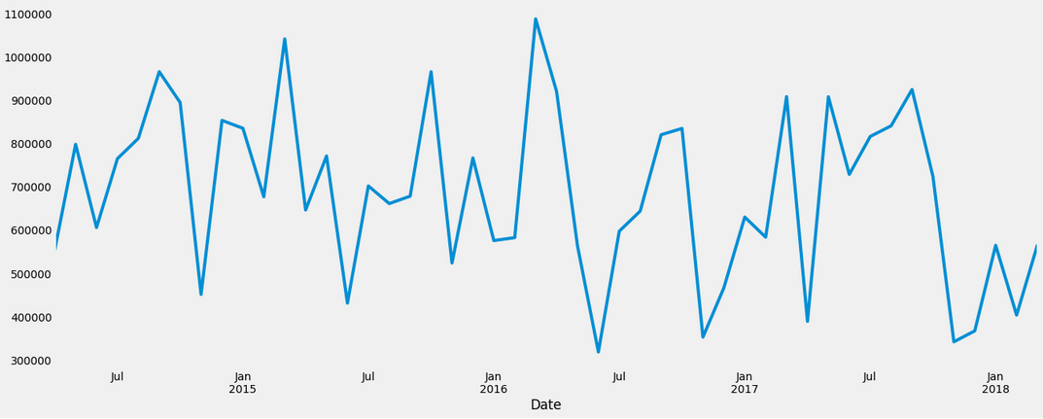

# Additive and Multiplicative Decomposition

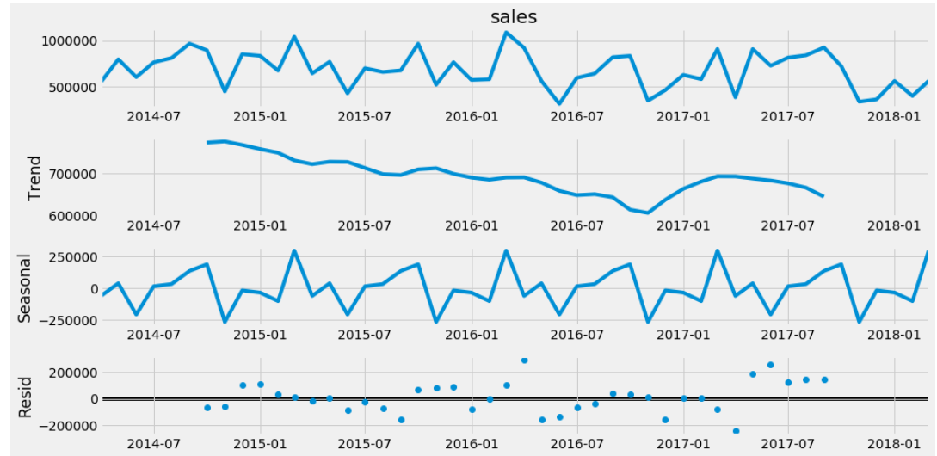 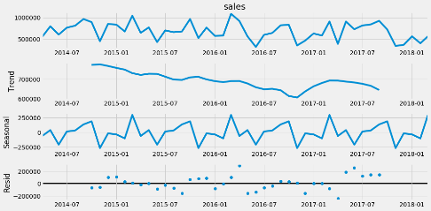

We observe there is seasonality in both the decompositions

# ACF and PACF Plots

Since the ACF plot is gradually decreasing and PACF plot suddenly cuts off to zero,

we will be needing a purely Seasonal AR Model. Let us see, if the Arima model gives us results

in accordance to this observation.

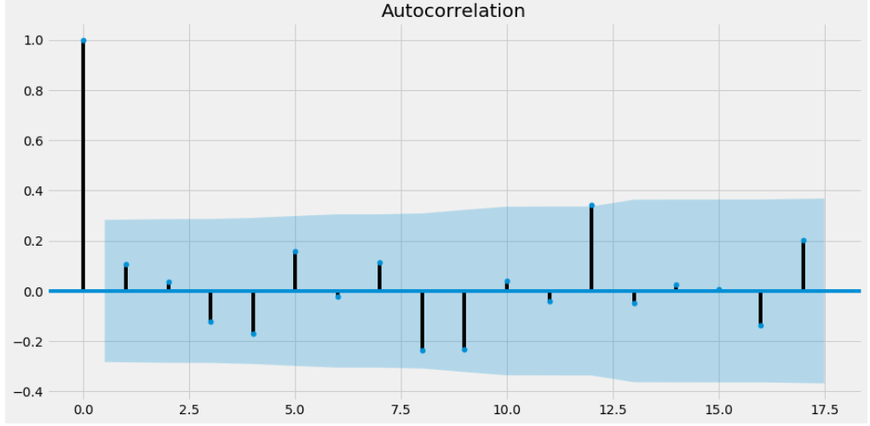 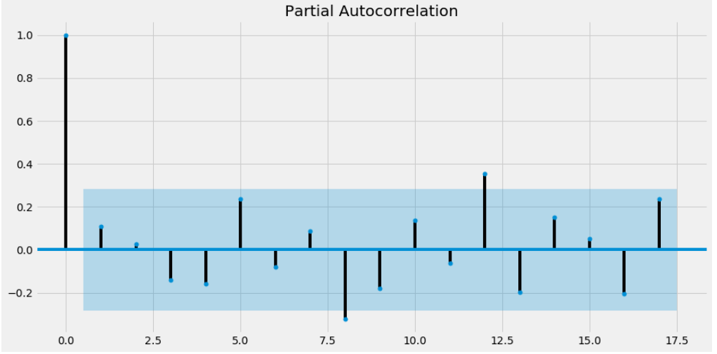

# Models

We have tried out various models and results shown below.



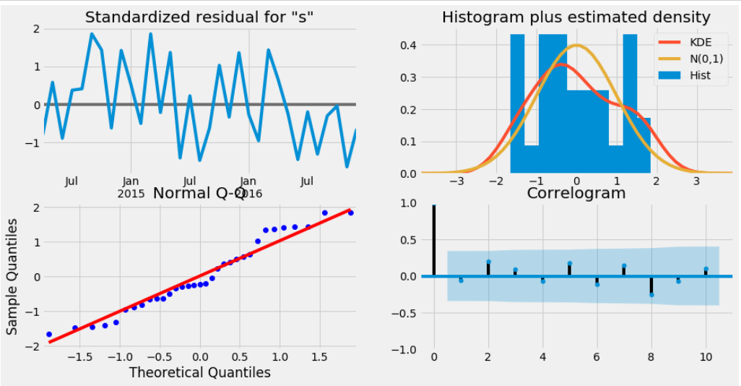

ARIMA have shown the best results for Pune region.

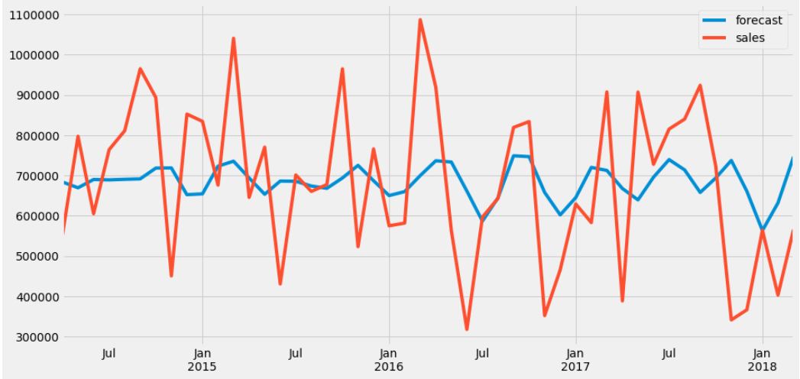

The above plot shows Actual vs Predicted data.

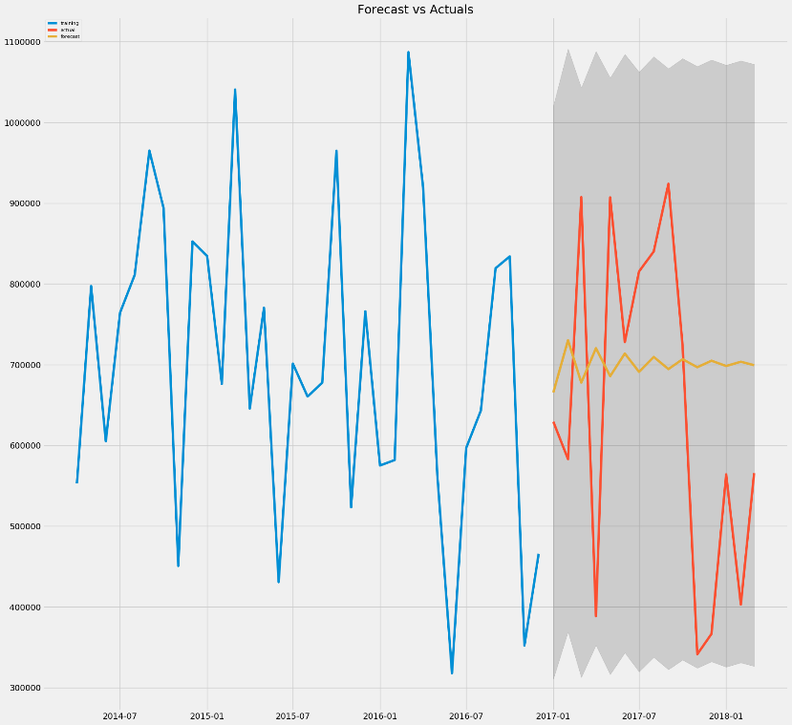

## Bangalore

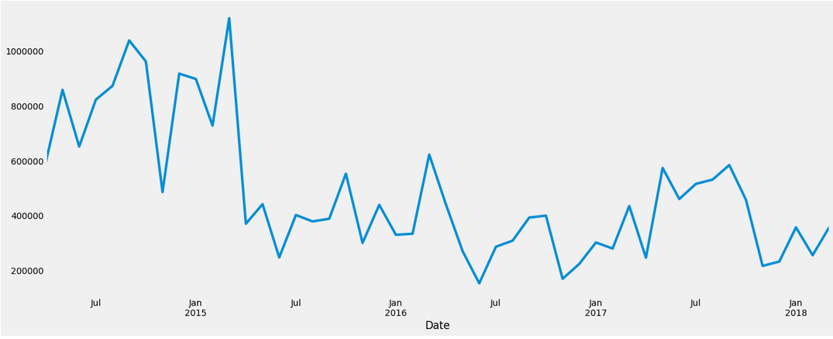

# Additive and Multiplicative Decomposition

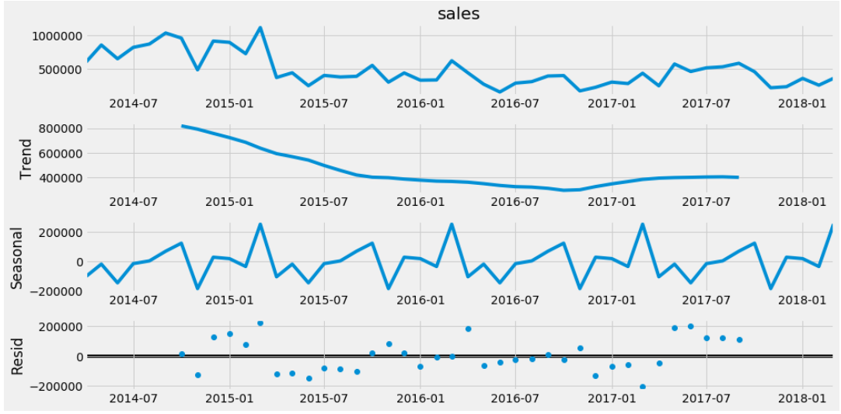 

We observe there is seasonality in both the decompositions

# ACF and PACF Plots

Since the ACF plot is gradually decreasing and PACF plot suddenly cuts off to zero,

we will be needing a purely Seasonal AR Model. Let us see, if the Arima model gives us results

in accordance to this observation.

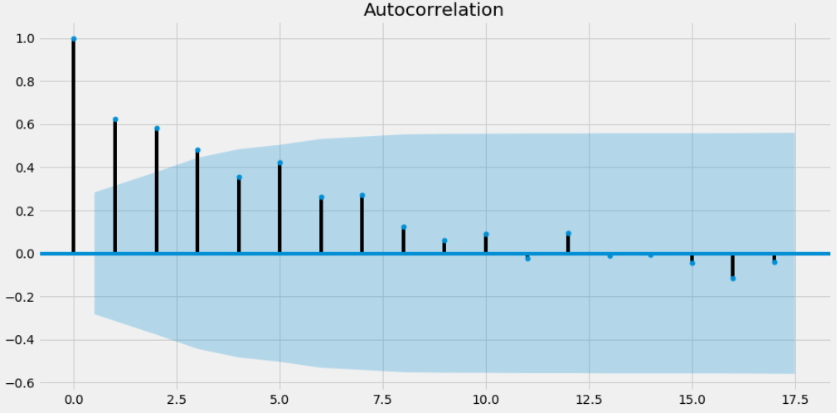 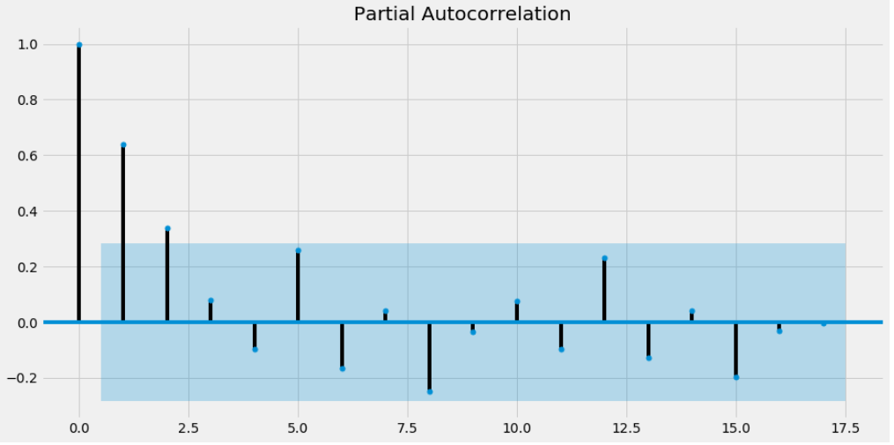

# Models

We have tried out various models and results shown below.



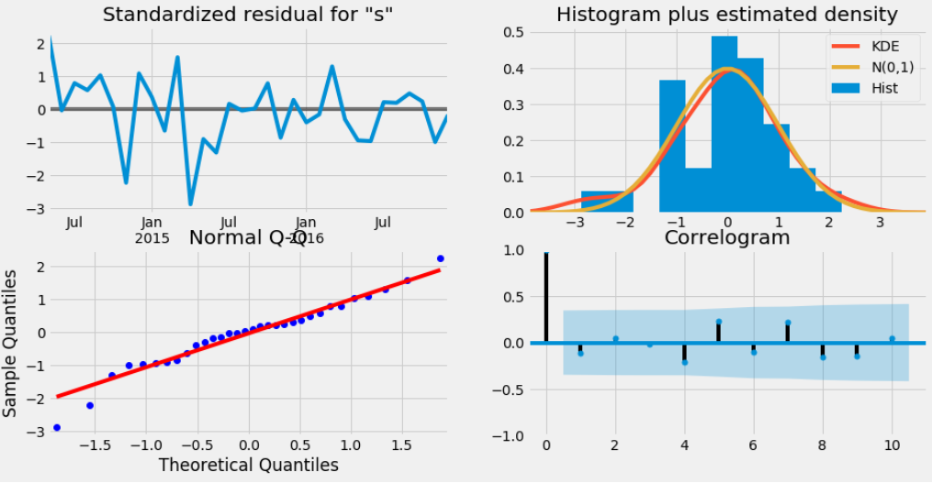

ARIMA have shown the best results for Bangalore region.

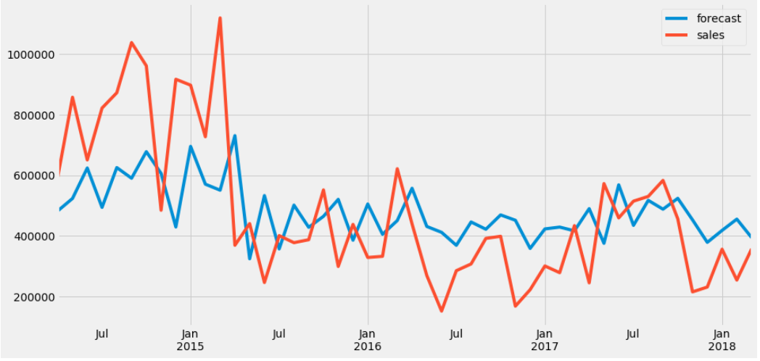

The above plot shows Actual vs Predicted data.

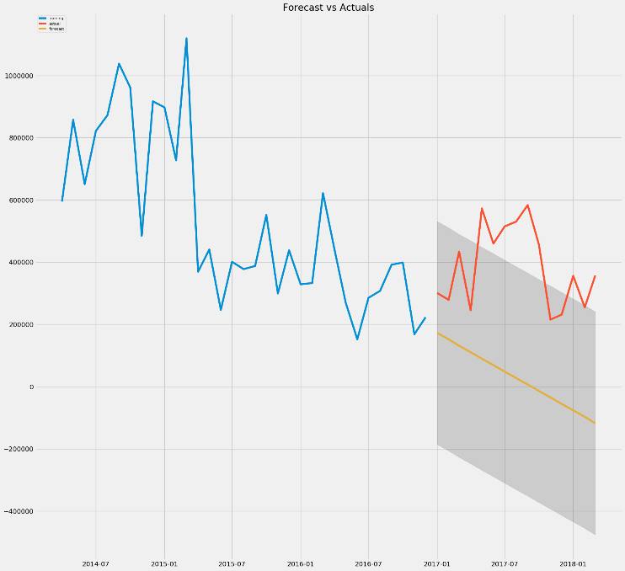

# Business Insights

* Food Processor do not have seasonal components. Mumbai ,Pune and Bangalore yields highest sales across the years, however sales forecast decreases over the years for Pune
* Other cities Ahmd, Kolkata and Hyderabad give good sales, its sales also declines as the years pass by
* Others cities such as Cochin and chennai yields less profit. We should reconsider sales and production of products in these areas

# Gas Stove

## Mumbai

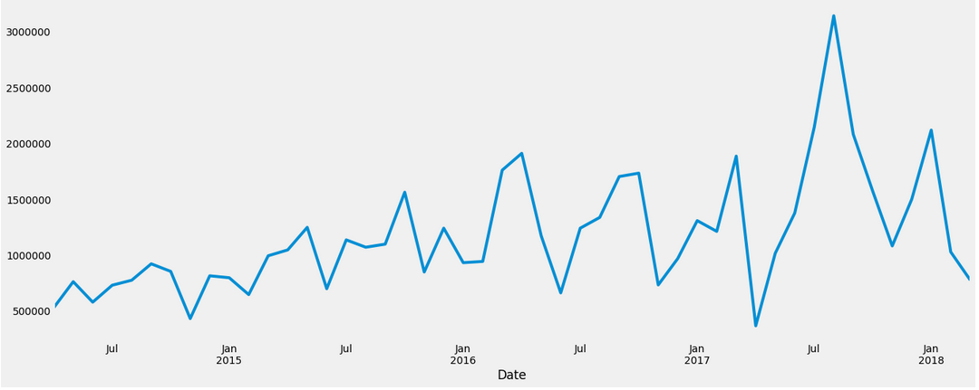

# Additive and Multiplicative Decomposition

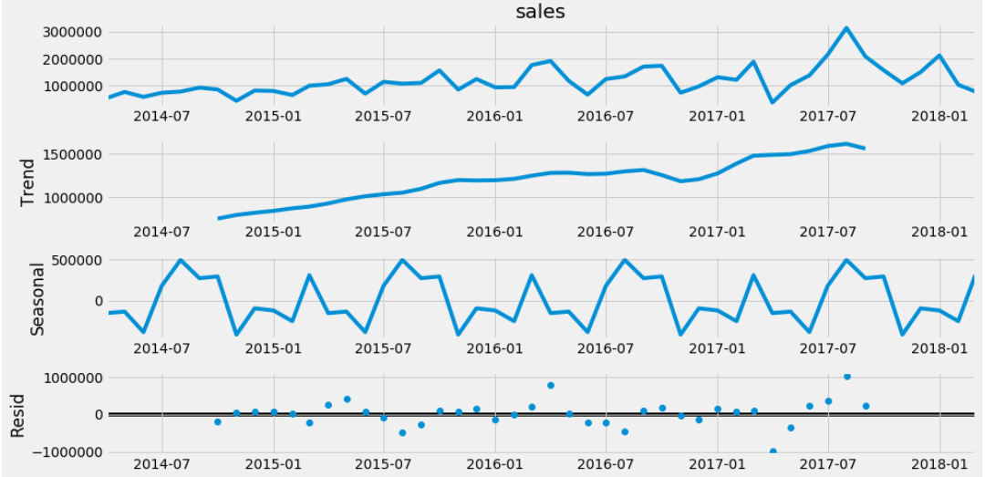 

We observe there is no seasonality in both the decompositions

# ACF and PACF Plots

Since the ACF plot is gradually decreasing and PACF plot suddenly cuts off to zero,

we will be needing a purely Seasonal AR Model. Let us see, if the Arima model gives us results

in accordance to this observation.

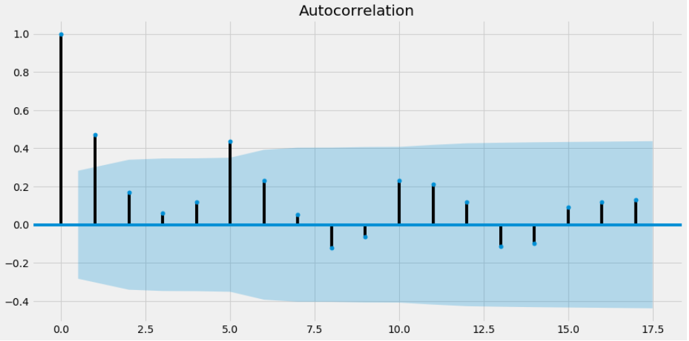 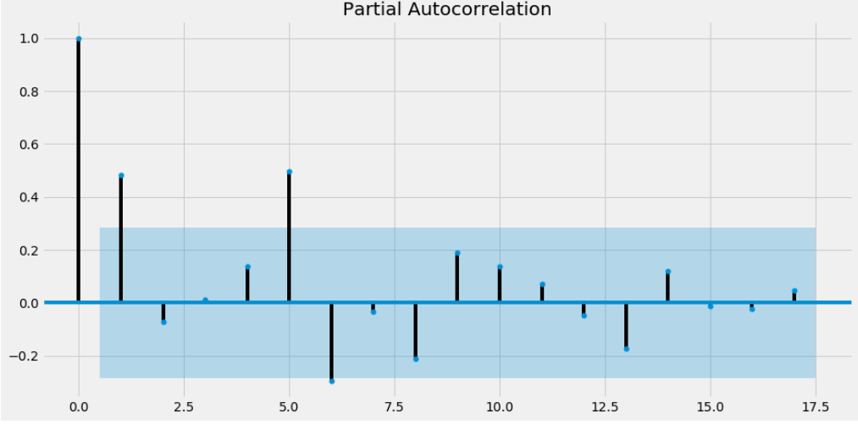

# Models

We have tried out various models and results shown below.



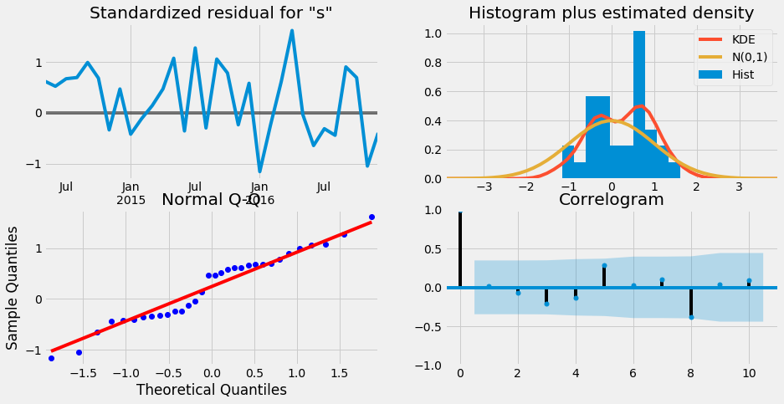

ARIMA have shown the best results for Mumbai region.

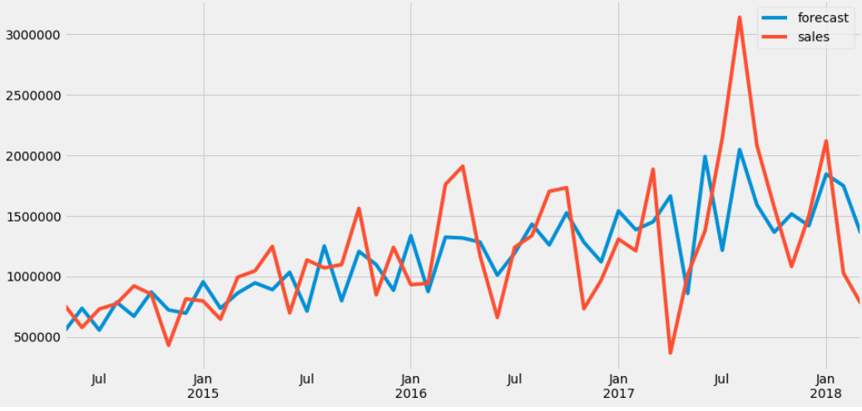

The above plot shows Actual vs Predicted data.

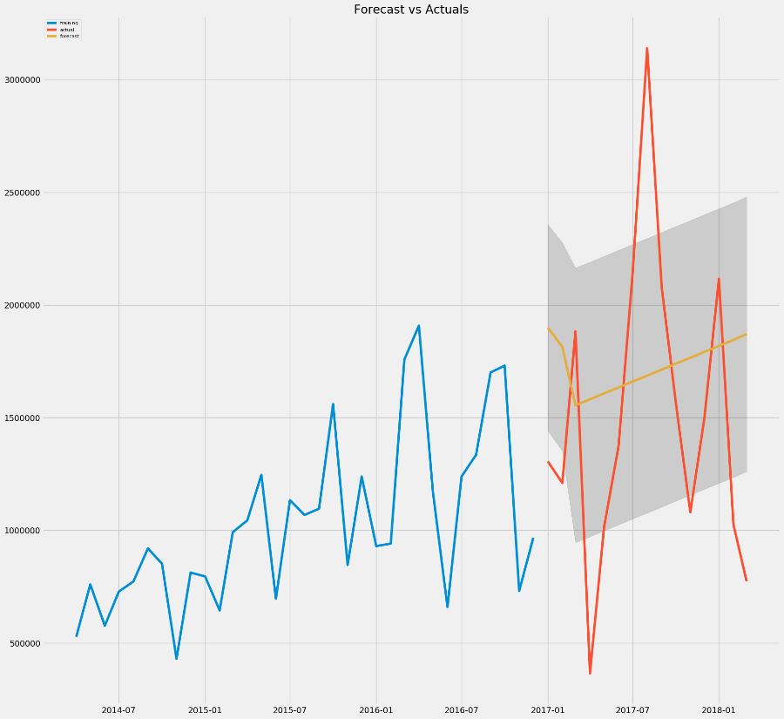

## Cochin

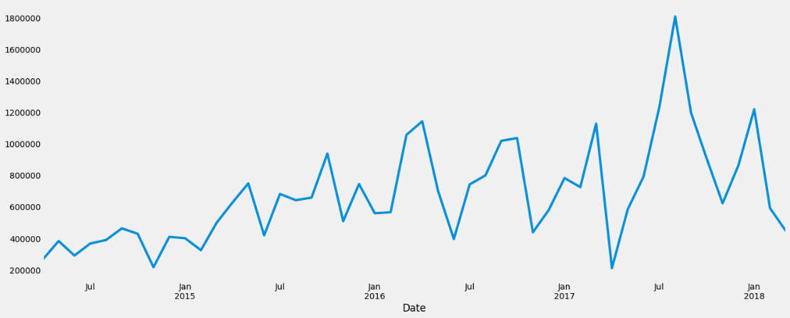

# Additive and Multiplicative Decomposition

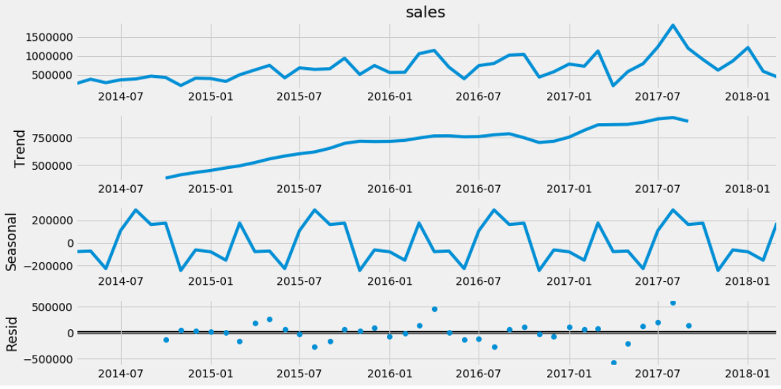 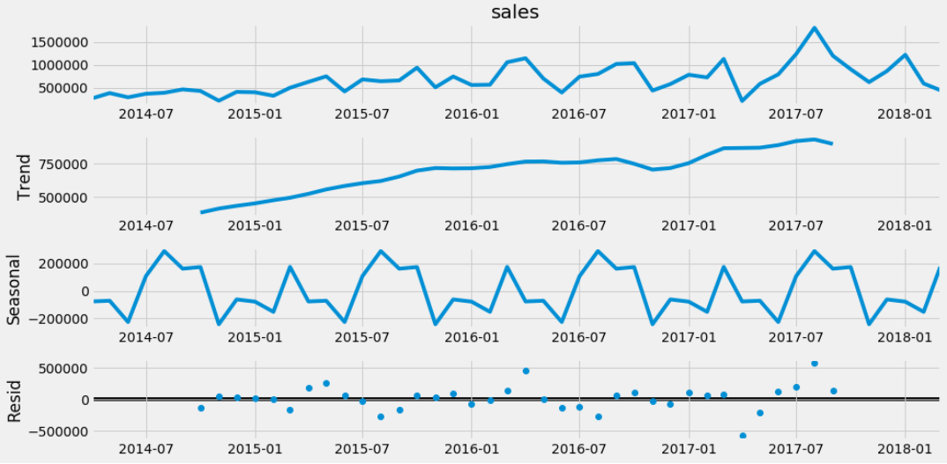

We observe there is no seasonality in both the decompositions

# ACF and PACF Plots

Since the ACF plot is gradually decreasing and PACF plot suddenly cuts off to zero,

we will be needing a purely Seasonal AR Model. Let us see, if the Arima model gives us results

in accordance to this observation.

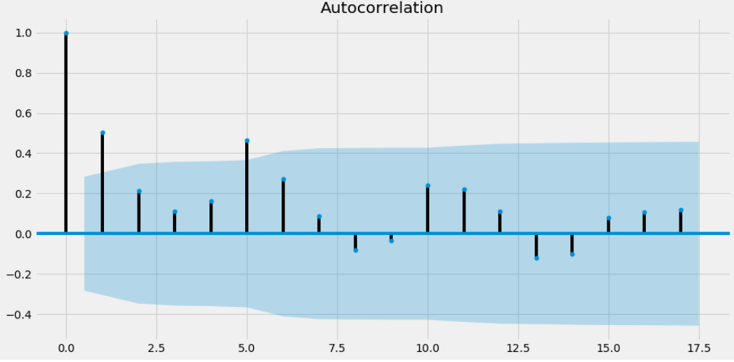 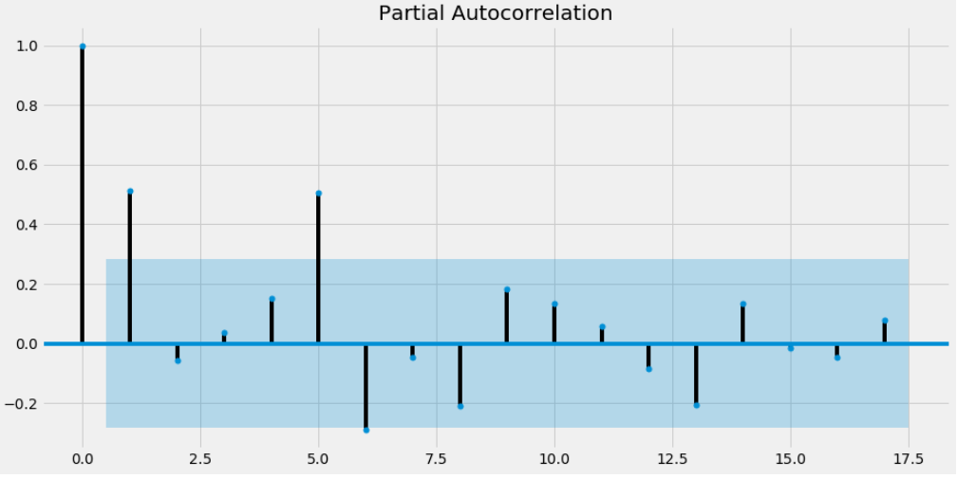

# Models

We have tried out various models and results shown below.



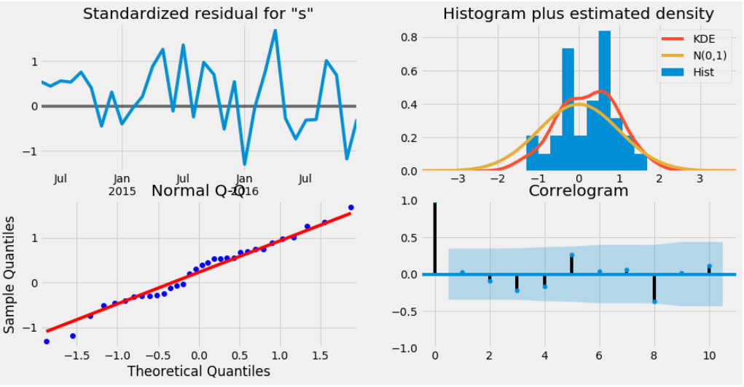

ARIMA have shown the best results for Cochin region.

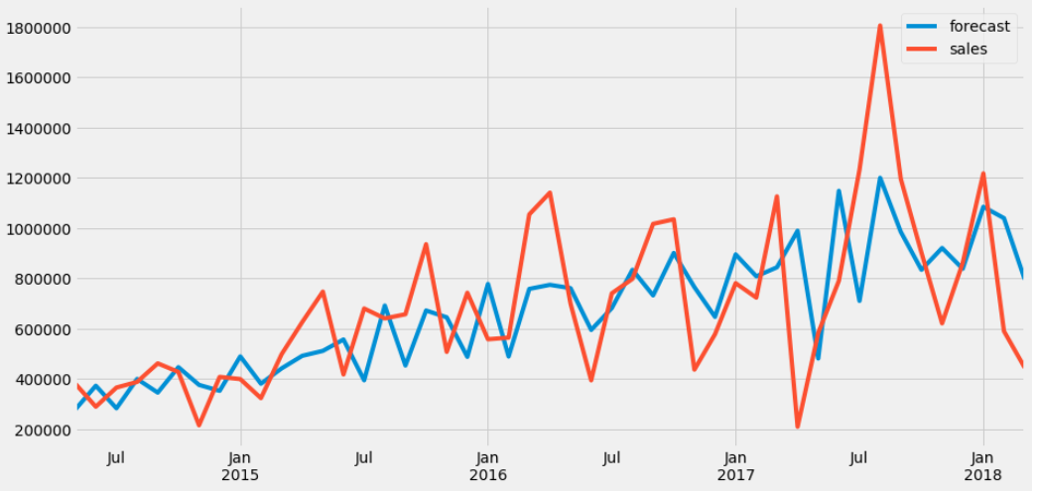

The above plot shows Actual vs Predicted data.

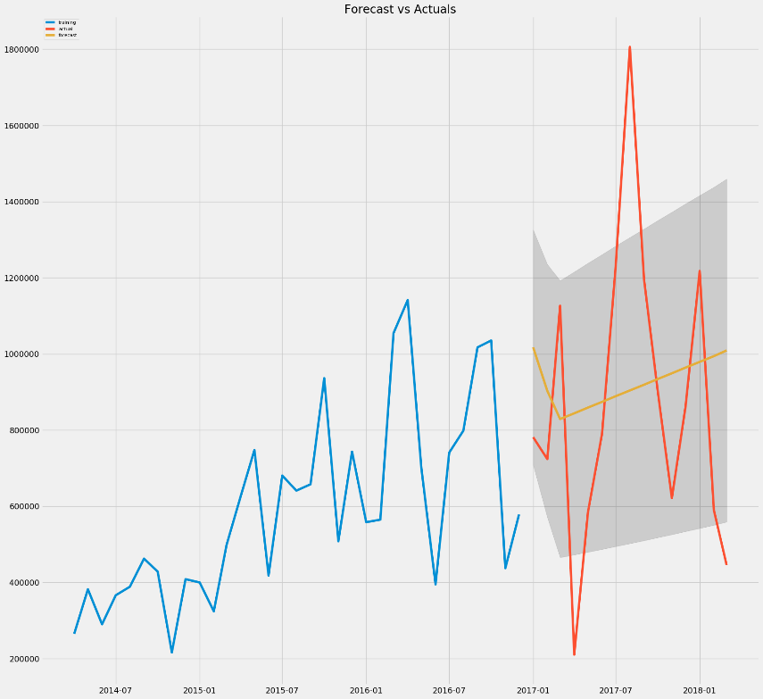

## Kolkata

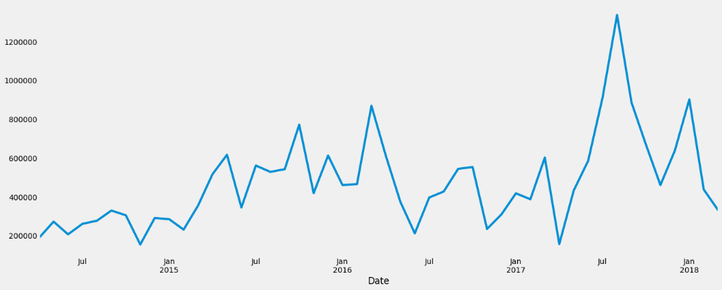

# Additive and Multiplicative Decomposition

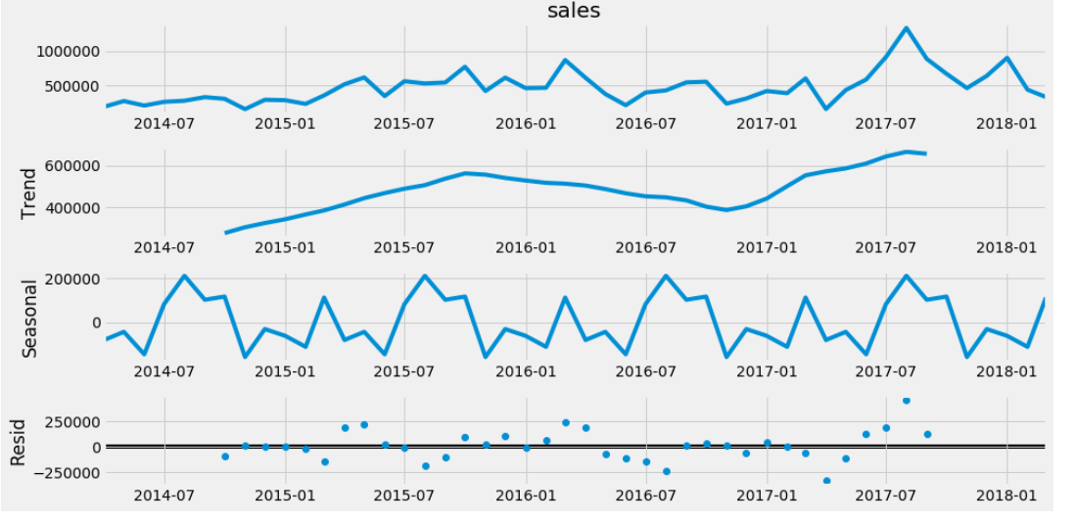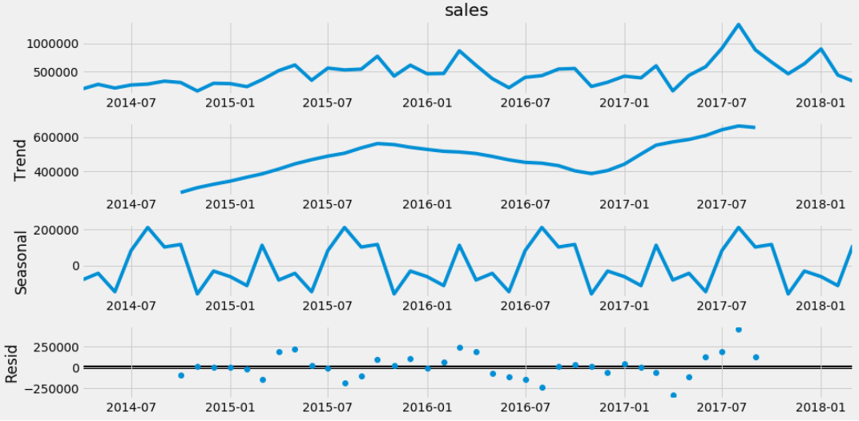

We observe there is no seasonality in both the decompositions

# ACF and PACF Plots

Since the ACF plot is gradually decreasing and PACF plot suddenly cuts off to zero,

we will be needing a purely Seasonal AR Model. Let us see, if the Arima model gives us results

in accordance to this observation.

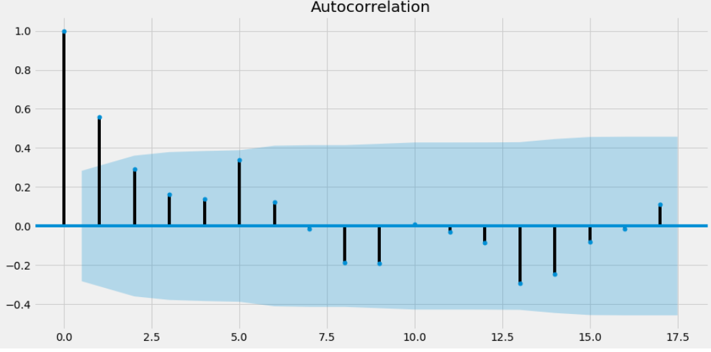 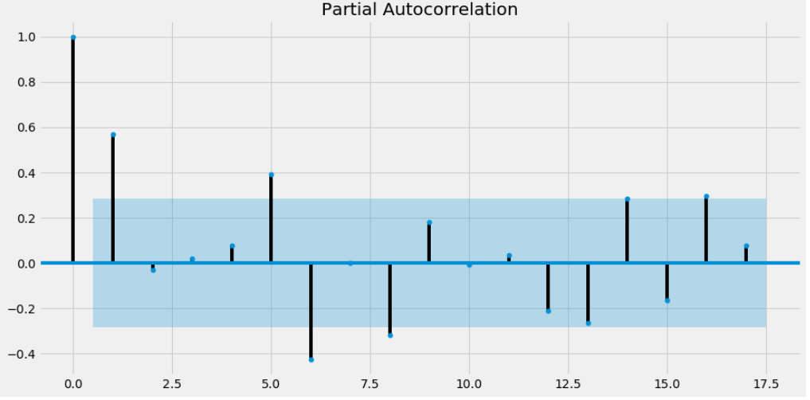

# Models

We have tried out various models and results shown below.



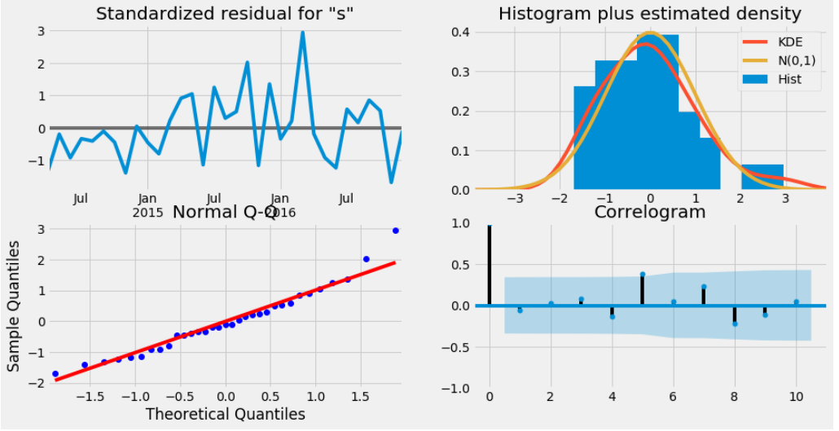

ARIMA have shown the best results for Kolkata region.

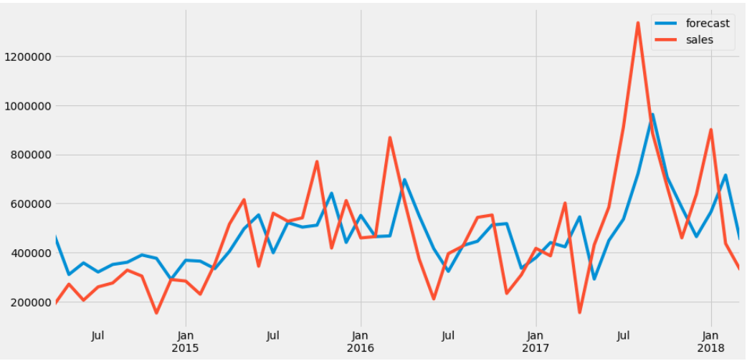

The above plot shows Actual vs Predicted data.

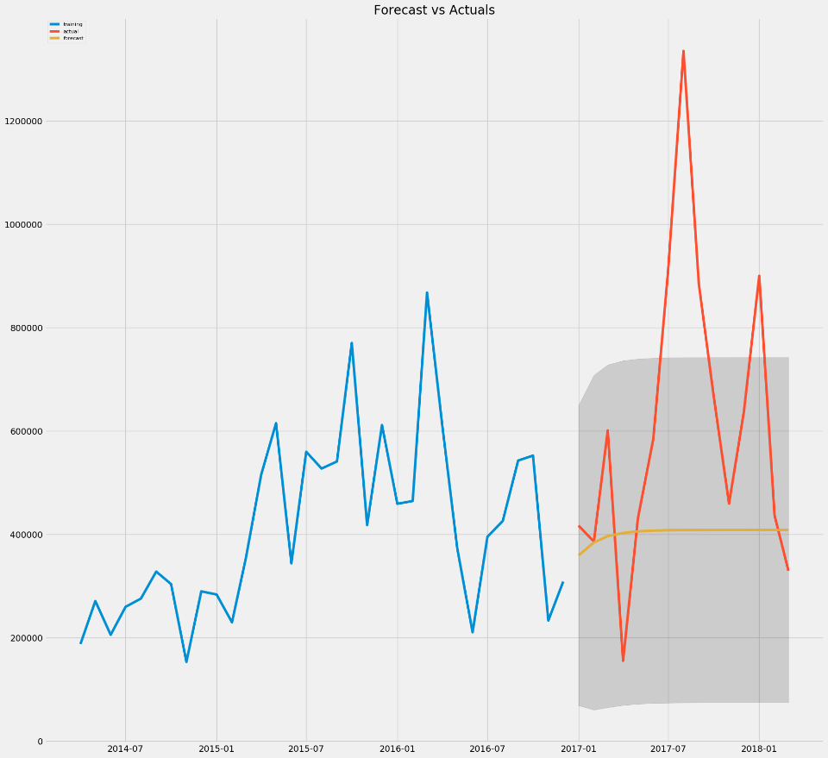

# Business Insights

* Gas Stove do not have seasonal components. Mumbai , Kolkata and Cochin yields highest sales across the years
* Other cities Hyderabad, Amhd and Chennai give good sales and its forecast also looks good in the upcoming years
* Others cities such as Delhi and bangalore yields less profit, however the profits are consistent through the year.
* All cities yields good sales from 2014 to 2018, hence sales is prone to go up in the upcoming years

# Induction Cookers

## Mumbai

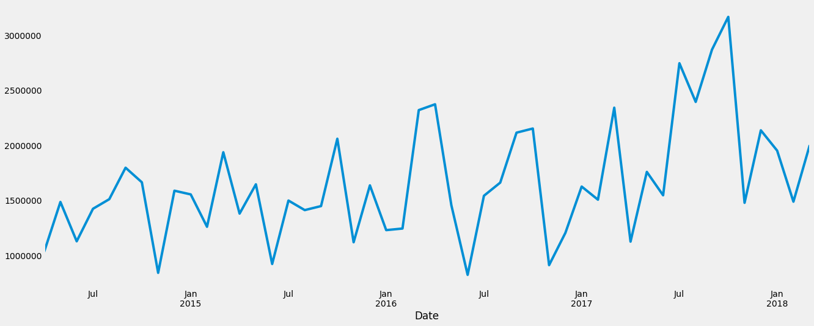

# Additive and Multiplicative Decomposition

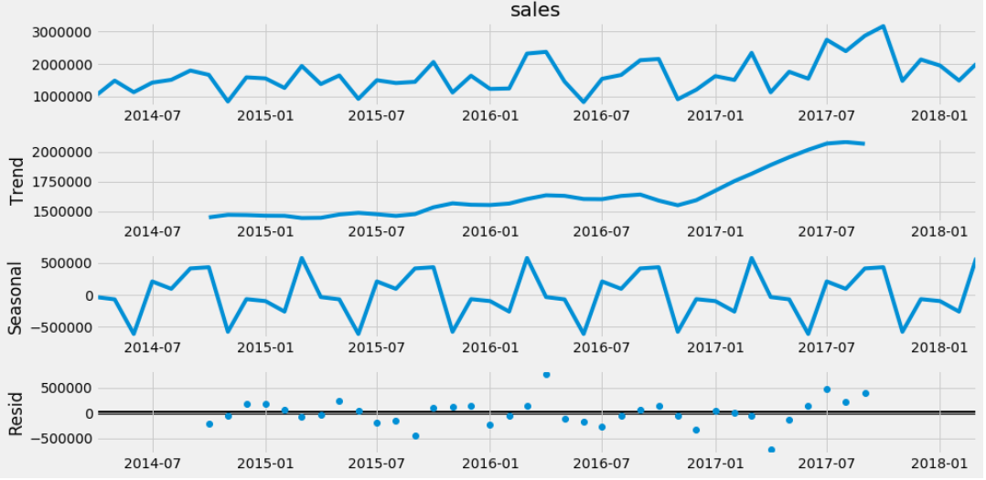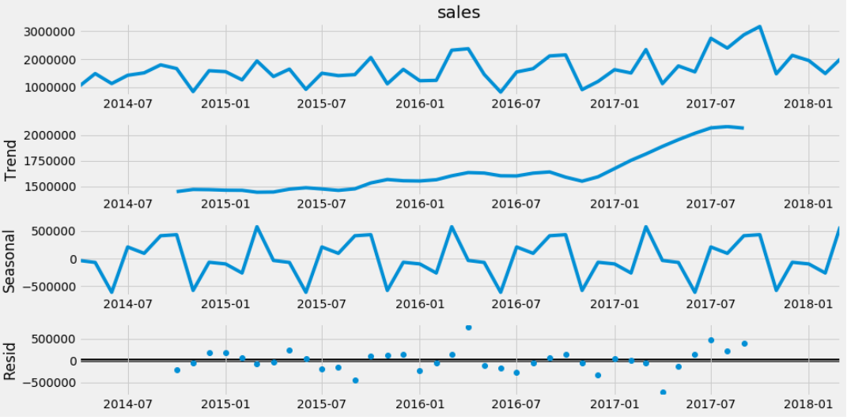

We observe there is no seasonality in both the decompositions

# ACF and PACF Plots

Since the ACF plot is gradually decreasing and PACF plot suddenly cuts off to zero,

we will be needing a purely Seasonal AR Model. Let us see, if the Arima model gives us results

in accordance to this observation.

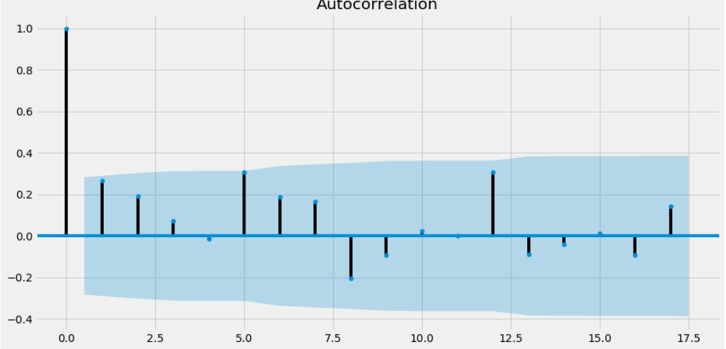 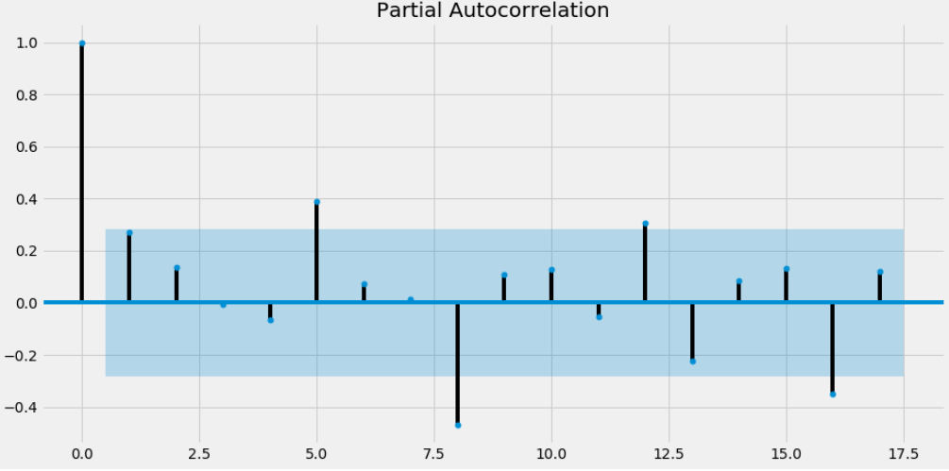

# Models

We have tried out various models and results shown below.



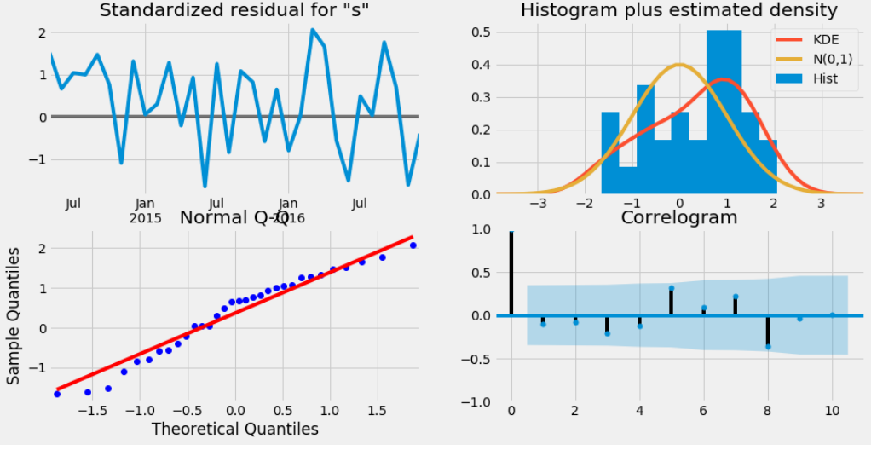

ARIMA have shown the best results for Mumbai region.

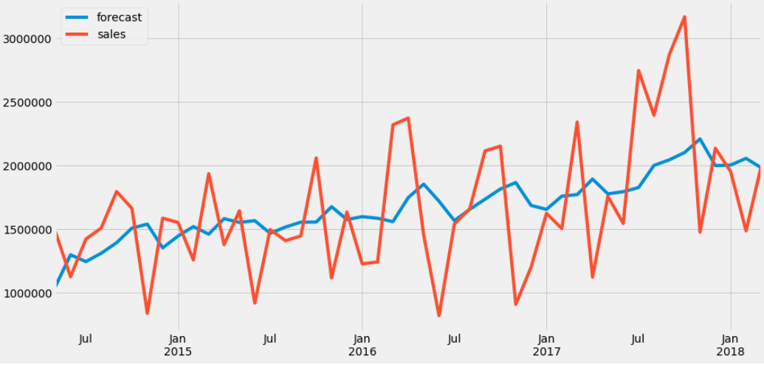

The above plot shows Actual vs Predicted data.

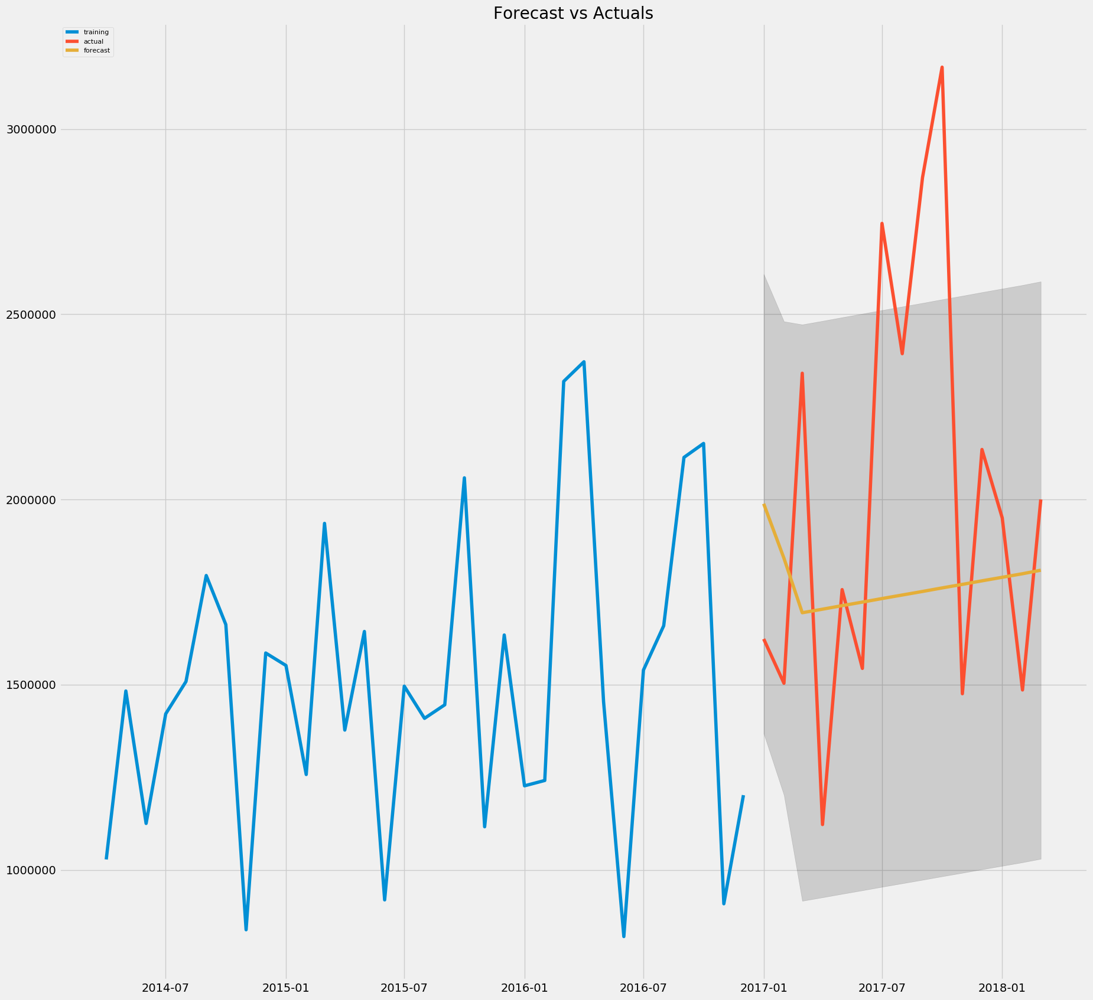

# Business Insights

* Induction Cooker do not have seasonal components. Mumbai , Kolkata and bangalore yields highest sales across the years
* Other cities Pune, Hyderabad and Ahmd give good sales and its forecast trend also looks good in the upcoming years
* Others cities such as Delhi and Cochin yields less profit, however the profits are consistent through the year.
* All cities yields good sales from 2014 to 2018, hence sales is prone to go up in the upcoming years

# Mixers

## Mumbai

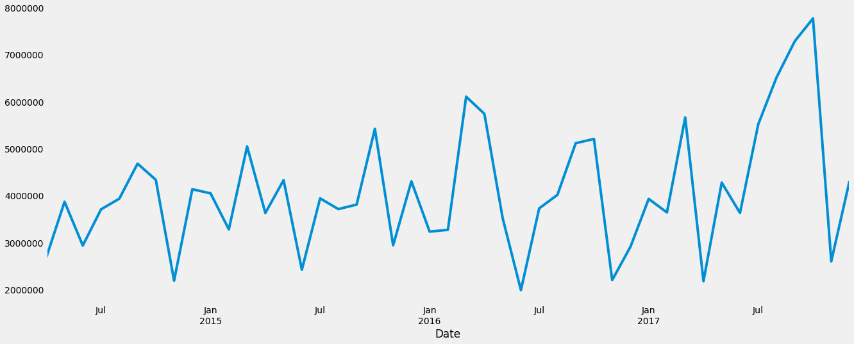

# Additive and Multiplicative Decomposition

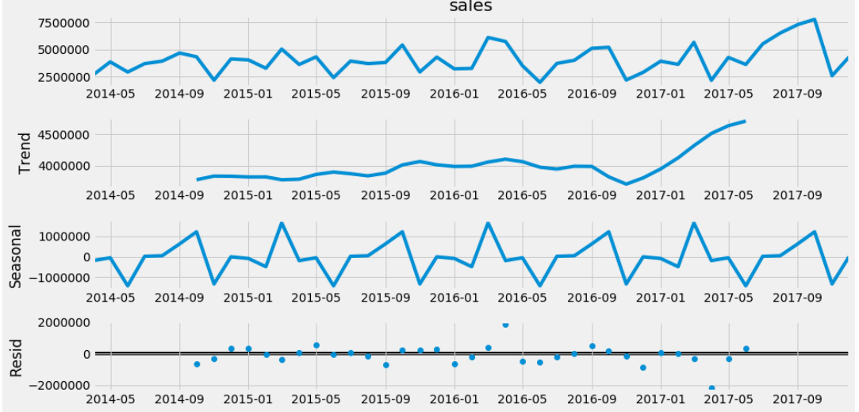 

We observe there is no seasonality in both the decompositions

# ACF and PACF Plots

Since the ACF plot is gradually decreasing and PACF plot suddenly cuts off to zero,

we will be needing a purely Seasonal AR Model. Let us see, if the Arima model gives us results

in accordance to this observation.

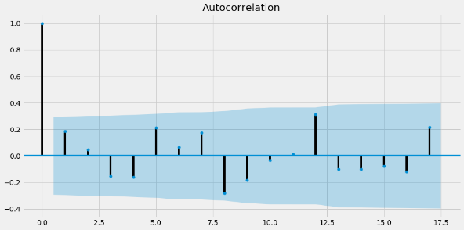 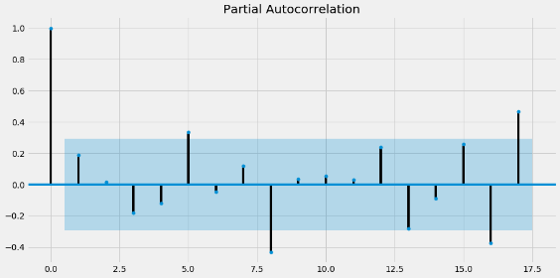

# Models

We have tried out various models and results shown below.

|  |  |  |
| --- | --- | --- |
| **RegressionOnTime** | 8.10E+06 | NaN |
| **NaiveModel** | 3.16E+06 | NaN |
| **SimpleAverageModel** | 3.73E+06 | NaN |
| **Alpha=0.166,SimpleExponentialSmoothing** | 3.40E+06 | 39.219725 |
| **Alpha=0.235,SimpleExponentialSmoothing** | 3.40E+06 | 39.219725 |
| **Alpha=0.005,Beta=0.0001,Gamma=0.0001,TripleExponentialSmoothing** | 2.66E+06 | 27.589682 |
| **Alpha=0.2,Beta=1.0,Gamma=0.5,TripleExponentialSmoothing** | 1.26E+06 | 32.82398 |
| **ARIMA(2,0,2)** | 3.28E+01 | 35.366281 |
| **SARIMA(0,0,0)(0,0,3)12** | 5.57E+13 | 100 |

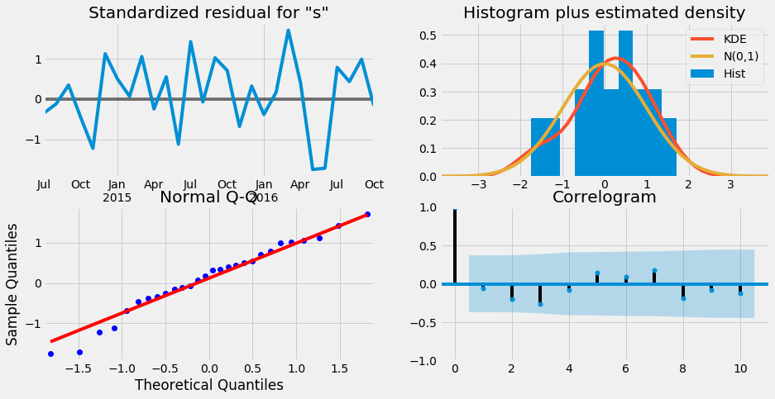

ARIMA have shown the best results for Mumbai region.

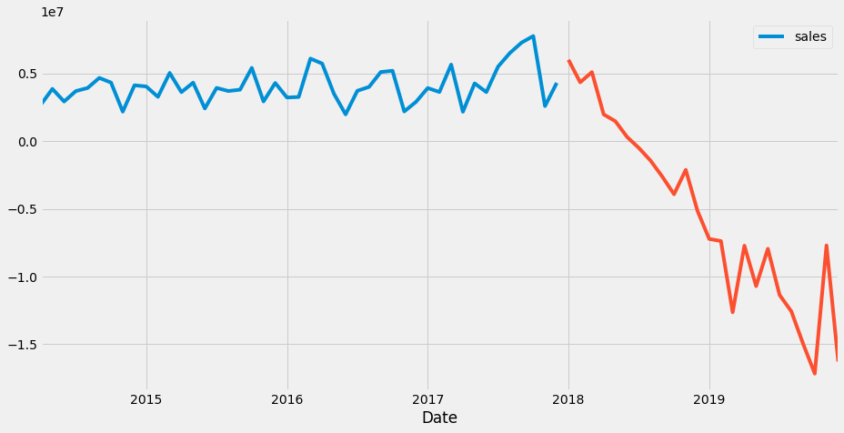

The above plot shows Actual vs Predicted data.

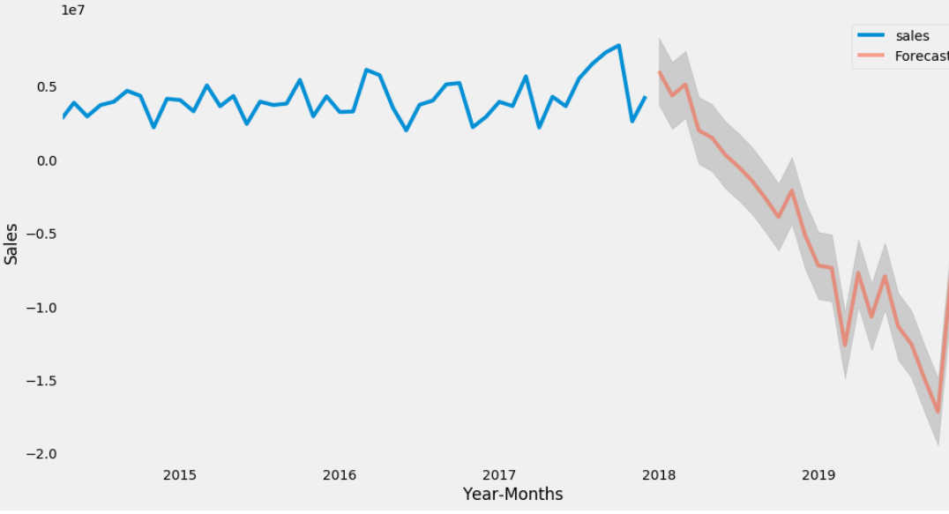



# Business Insights

* Mixers do not have seasonal components. Mumbai , Kolkata and bangalore yields highest sales across the years
* Other cities Pune, Chennai and Delhi give good sales and its forecast trend also looks good in the upcoming years except pune, which has downward trend of sales
* Others cities such as Pune and Chennai yields less profit however pune, which has downward trend of sales

# Oven Toaster Grill

# Business Insights

* OTG do not have seasonal components. Mumbai , Kolkata and Hyderabad yields highest sales across the years
* Other cities Ahmd, Bangalore and Delhi give good sales and its forecast trend also looks good in the upcoming years
* Others cities such as Pune and Chennai yields less profit however pune, trend goes good sales across the years.

# Steam Iron

# Business Insights

* Steam Iron do not have seasonal components. Mumbai , Bangalore and Hyderabad yields highest sales across the years and the forecast looks a flat line in the ARIMA model.
* Other cities Ahmd, Kolkata and Pune give good sales and its forecast trend also looks good in the upcoming years
* Others cities such as patna and cochin yields less profit.

# Overall Insights

* Even though cities have highest sales over the years , the forecast for some products in the cities have decline of trend, hence those products needs extra promotional offers to boost sales in the upcoming years and plan the production
* Cities with less sales would give upward trend for sales, those cities must be concentrated for more production and additional promotional offers such as freebies and discounts during offseason should be offered.
* Very low sales products should be reconsidered for production and drop the products in those because it would give them a loss.
* ARIMA model gave the beset results for 80 percentage of the dataset and triple exponential for seasonal product coolers.
* For model tunning, SARIMA, Simple and Simple average models have been used.